Group Policy and File System Permissions

Yogaraj Govindarajalu Prabagaran

# Table of Contents

Table of Contents 2

Group Policy and File System Permissions 3

Parts 3

Description 3

Preparation 4

Observations 5

Screenshots 7

Reflection 48

References 50

# Group Policy and File System Permissions

# Parts

## Description

Group Policy

The central part of the exercise involves creating Active Directory objects and file system objects, followed by configuring Group Policy settings.

The primary steps are as follows:

Create security groups and users on the Domain Controller.

On the Management Server VM, set up a folder and download files.

Configure Group Policy settings and observe the effects, including desktop wallpaper changes, group policy inheritance, and enforcing GPO links.

Modify security filtering, apply policies to specific groups, and note the resulting desktop wallpapers.

Configure firewall settings and use the Group Policy Results Wizard to analyze the impact of the changes.

File System Permissions

In this exercise, I aim to gain hands-on experience configuring NTFS permissions in a Windows environment.

Part 1: Create Users and Groups

On the Domain Controller, I'll create an Organizational Unit (OU) called Kitchener/Users and populate it with three users and three groups.

I'll then add users to specific groups.

Part 2: Configure and Test File System Permissions

This part involves working on a Member Server and includes multiple tasks.

I'll start by reviewing default permissions on a folder named Data1 and examining existing ACEs (Access Control Entries).

I'll then delve into effective permissions, experimenting with Deny permissions, breaking inheritance, and removing ACEs to understand their effects on file and folder access.

The exercise also covers access-based enumeration (ABE) and role-based access control (RBAC) for managing a shared Publications folder.

Throughout the exercise, I'll analyze how NTFS permissions work in practice and understand their implications for file and folder security.

## Preparation

The Group Policy Exercise's core tasks would require ensuring everything is set up correctly. Here's some of the stuff I double-checked:

Environment Setup: First, I must ensure that my Windows Server VM is ready for configuration. This VM is essential for this exercise. Also, it should be joined to the domain I created in the initial setup, Ygovindarajalup8461Labs.local.

Domain Confirmation: It's essential to double-check that the domain I created in the previous lab is accessible and running smoothly. This domain is the foundation for all the Group Policy configurations I will work on.

Resource Check: To make things go smoothly, I must have the "wallpapers.zip" file on hand.

Remote Desktop Access: I must confirm that I have remote desktop access to my Windows Server VM. I'll need this access for multiple tasks in the exercise.

Permissions and Credentials: I must ensure I have the correct licenses and credentials to perform administrative actions on the domain and VMs. I'll create Active Directory objects and configure Group Policy settings, making access rights critical.

By taking these preparation steps, I can be confident that my environment is ready and that I have all the resources and access I need to smoothly complete the Group Policy Exercise and tackle the tasks outlined in the main document.

File System Permissions- Preparation Section

Before I jump into the File System Permissions Exercise, there are some essential preparations I need to make:

Environment Setup: I need access to the required virtual machines (Domain Controller, Member Server, and Client VM).

Users and Groups: I should confirm that I have the necessary users and groups in my Active Directory environment. Specifically, I need to ensure that the Kitchener/Users OU exists and contains the users (Jane Doe, John Jones, and Bob Smith) and groups (Group 1, Group 2, and Group 3).

Remote Desktop Access: It's crucial to ensure that I have remote desktop access to both the Member Server and Client VMs. These connections will be essential for various tasks during the exercise.

Resource Availability: I must verify that I can access the "wallpapers.zip" file. This file will be required for specific tasks within the exercise.

Administrative Control: Lastly, I needed to confirm that I have the proper administrative credentials and permissions to create, modify, and manage users, groups, and permissions within the Active Directory and file system.

By completing these preparations, I'll be able to successfully navigate the File System Permissions Exercise, grasp the intricacies of NTFS permissions, and effectively manage access control within a Windows environment.

## Observations

Exercise 1- Group Policy Exercise:

Desktop Wallpaper Policy: When I created a new Group Policy Object (GPO) named "Stewie" and linked it to the domain, I configured the desktop wallpaper policy to map to the "Stewie.jpg" file. Logging in via remote desktop using the "smith" account, I observed the desktop wallpaper change to "Stewie.jpg."

Group Policy Inheritance Blocking: After blocking group policy inheritance on the Employee OU, forcing a group policy update, and logging out, I expected the wallpaper to remain "Stewie.jpg" when logging in with the "Smith" account. However, it didn't change, suggesting that inheritance blocking had an impact.

Enforced GPO Link: When I enforced the link for the "Stewie" GPO on the domain, forced a group policy update, and logged out, the wallpaper changed to "Stewie.jpg" when logging in with the "Smith" account.

Turning off Inheritance Blocking: After disabling group policy inheritance blocking on the GP OU and stopping the enforcement of the "Stewie" GPO, the wallpaper remained "Stewie.jpg" when logging in with the "smith" account.

Kitty GPO Configuration: Creating a new GPO named "Kitty" and linking it to the domain, I configured the desktop wallpaper policy to map to the "Cat.jpg" file. Logging in with the "smith" account, the wallpaper changed to "Cat.jpg."

Processing Order Reversal: Reversing the processing order of the "Stewie" and "Kitty" GPOs didn't immediately affect the wallpaper when logging in with the "Smith" account. This suggests that the order of GPOs can be significant.

Turning off the Link to Kitty GPO: After turning off the link to the "Kitty" GPO, the wallpaper remained "Cat.jpg" when logging in with the "smith" account.

Puppy GPO Configuration: Creating a new GPO named "Puppy" and linking it to the Employees OU, I configured the desktop wallpaper policy to map to the "Dog.jpg" file. Logging in with the "smith" account, the wallpaper changed to "Dog.jpg."

Security Filtering and Group Membership: By modifying security filtering on the "Stewie" and "Cat" GPOs, I ensured they were only processed by specific groups. When logging in with the "Smith" account, the wallpaper was "Stewie.jpg" as expected, while the "Jones" account had "Cat.jpg" as the wallpaper.

Administrator Account Configuration: Logging in with the administrator account, I configured the firewall to allow policy results reporting by enabling specific rules related to remote event management and Windows Management Instrumentation (WMI).

Changing Security Filtering for Stewie and Cat GPOs: By changing security filtering for the "Stewie" and "Cat" GPOs to be processed by "Authenticated Users," I executed the Group Policy Results Wizard, noted the scan results, and observed the events related to group policy processing.

These observations helped me understand how Group Policy configurations and settings influence the behavior of the Windows environment, including desktop wallpaper policies, group policy inheritance, security filtering, and user-specific settings.

Exercise 2: INFO8461 File System Permissions Exercise - Observations

Reviewing Default Permissions: When I reviewed the permissions on the "Data1" folder, I noticed the default permissions set on it. I selected each security principal and noted their associated permissions.

Practical Permissions Analysis: Using the "Effective Access" tab, I checked the permissions for the "John Jones" account. I observed that "John" had permissions, and they matched those listed in the previous step. Additional permissions were also noted. These effective permissions override the basic ones. The "Special" permission for "Users" was also checked, and advanced permissions were shown.

Testing Data1 Share: Logging in with the "John Jones" account on the Client VM, I attempted to create a text file and a folder in the "Data1" share. I could make both, indicating that default permissions allow users to create content.

Access for Other Users: When logging in with the "Jane Doe" account on the Client VM and navigating to the "Data1" share, I could see the files and folder created by "John Jones." I could view the contents of the file, change its contents, create a text file, and modify the folder created by "John Jones." This indicated that default permissions allowed considerable access when creating volumes in Windows.

Determining Specific Permissions: As the admin account, I examined permissions on "John's" text file to see if "Jane" could view but not modify it. I noted an ACE that allowed "Jane" to view the content without modification.

Permissions for Creating Files: I also looked at permissions on "John's" folder to see if "Jane" could create files. I identified an ACE that would allow "Jane" to create files in the folder, along with the source of that ACE.

These observations helped me understand how default permissions, effective permissions, and specific ACEs affect file and folder access in a Windows environment. It also sheds light on how permissions can be configured to grant or restrict access to different users.

## Screenshots

Group Policy:

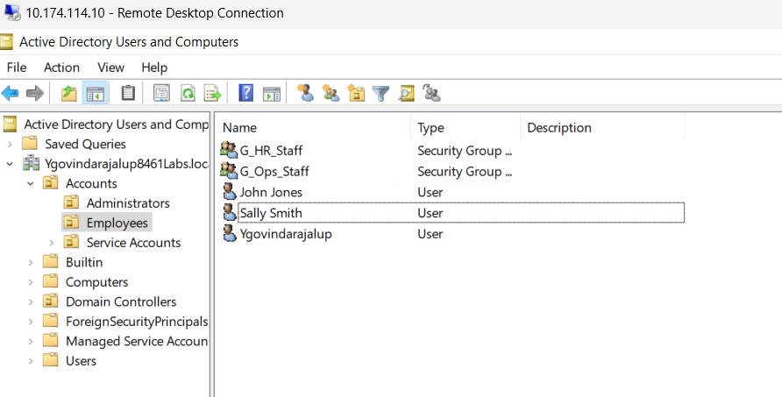

This screenshot displays the Employees OU Section in the Domain Controller VM.

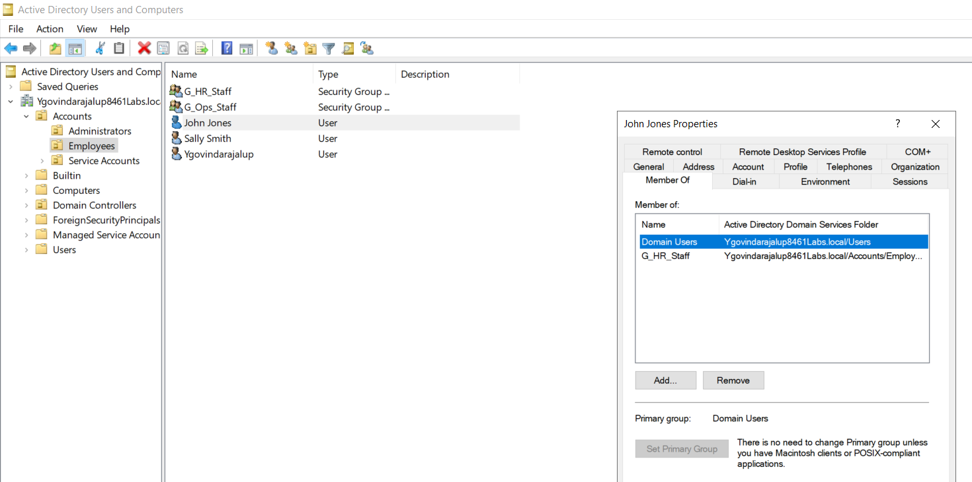

This Screenshot displays the addition of John Jones to the Domain Users.

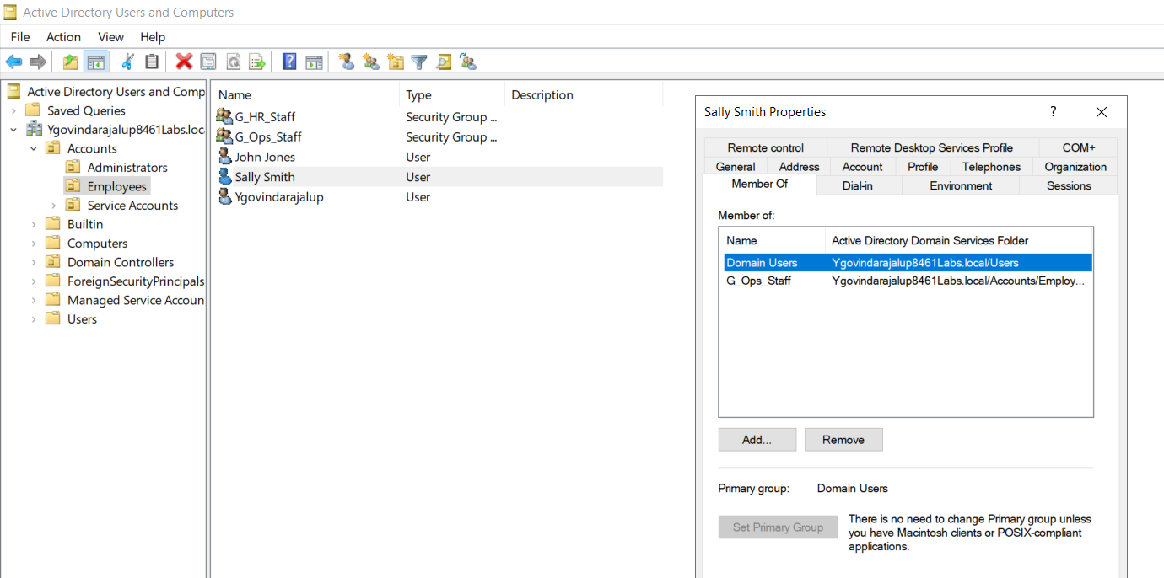

This Screenshot displays the addition of Sally Smith to the Domain Users.

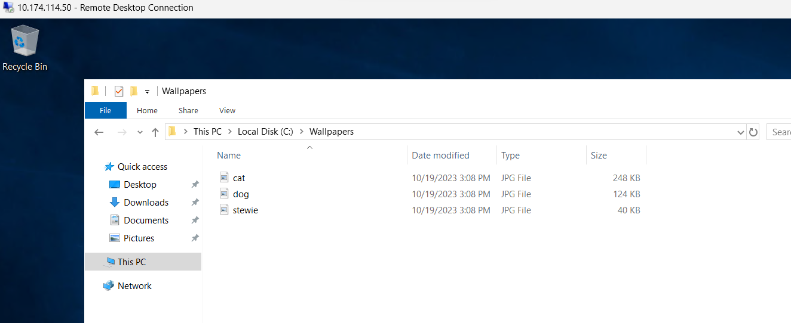

This screenshot shows the successful completion of the download of the “Wallpapers” folder.

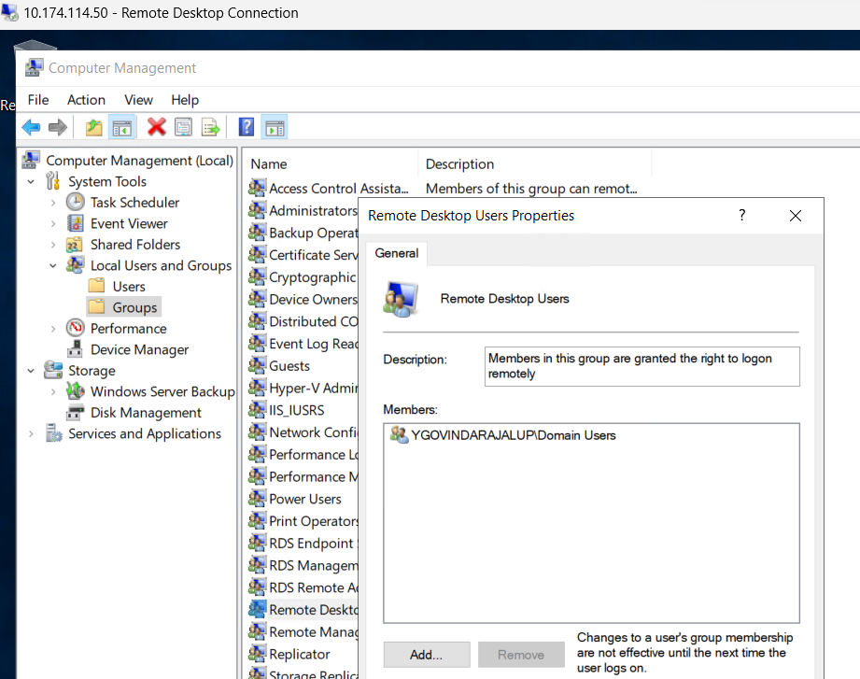

This screenshot showcases the successful addition of the Domain-Users group to the local Remote Desktop Users group to allow all users to connect via remote desktop.

Consuming Windows Network Shares (Jim Dickson, 2019, 0:00)

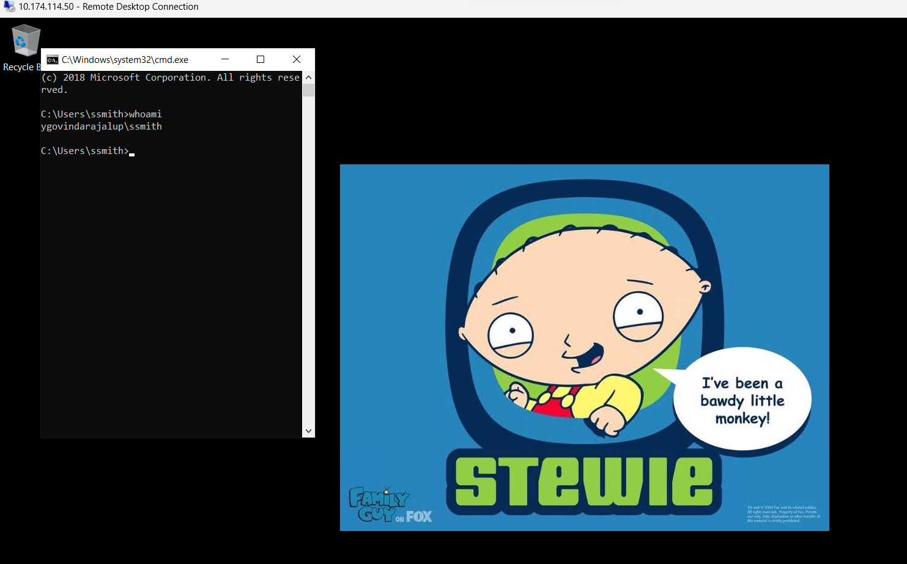

Creating a New GPO (Stewie)

I created a new Group Policy Object (GPO) named "Stewie" in this screenshot and linked it to the domain. I configured the desktop wallpaper policy to map to the "Stewie.jpg" file. I then connected to my Windows Server VM via remote desktop using the "Smith" account. The desktop wallpaper reflects the "Stewie.jpg" file configured in the GPO.

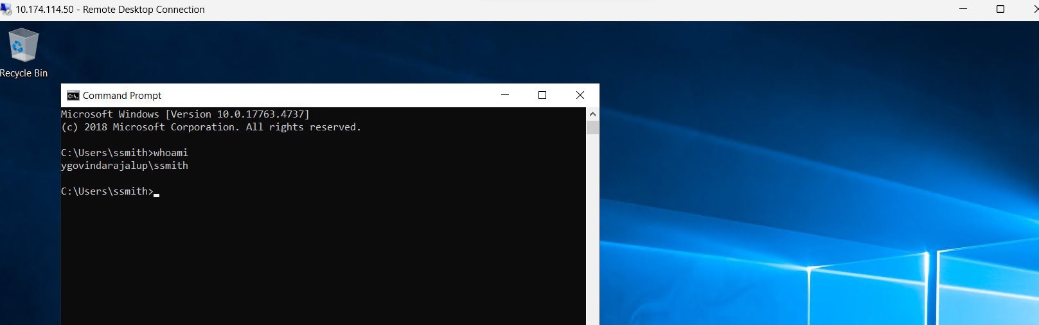

Blocking Group Policy Inheritance

I blocked group policy inheritance in this screenshot on the "Employee OU." After forcing a group policy update and logging out of the Windows Server VM, I observed the expected wallpaper change for the "Smith" account. Despite inheritance blocking, the desktop wallpaper reflects the policy configured in the "Stewie" GPO.

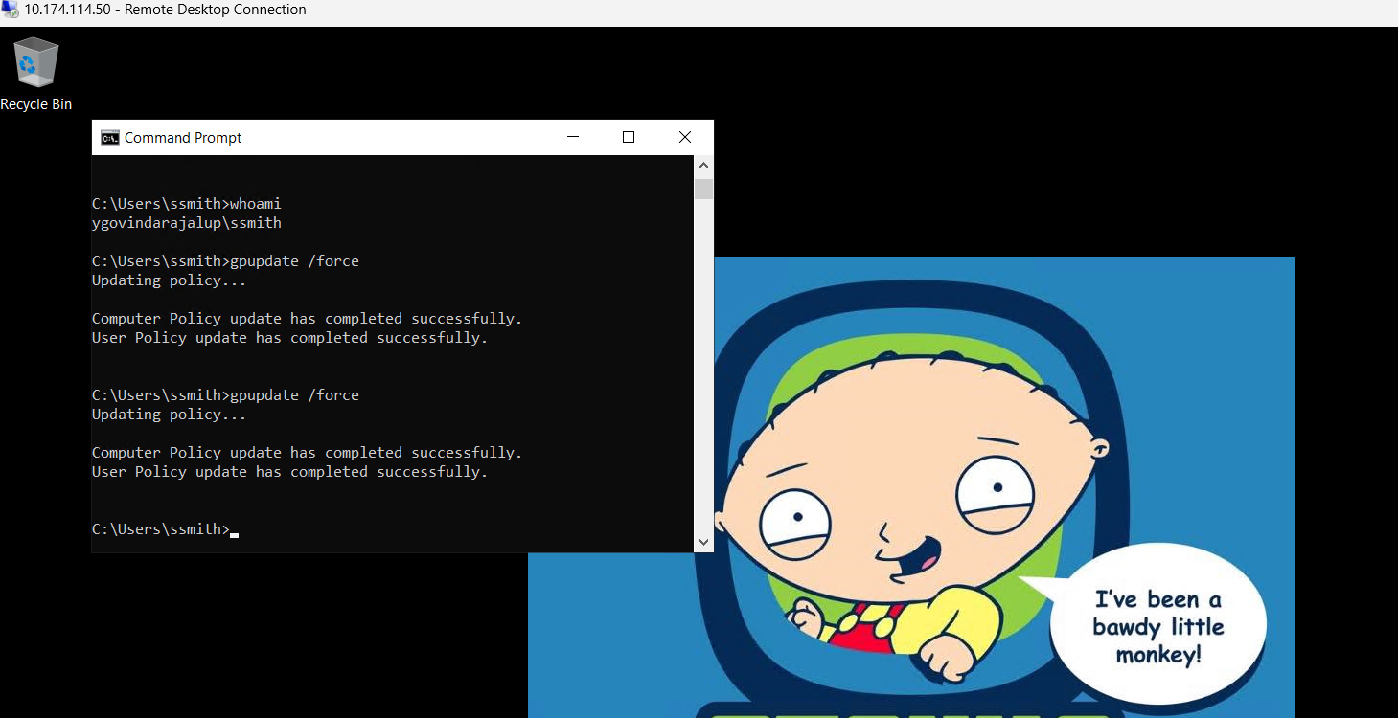

Enforcing GPO Link (Stewie)

I enforced the link for the "Stewie" GPO on the domain. After forcing a group policy update and logging out of the Windows Server VM, I noted the expected wallpaper for the "Smith" account, which reflects the policy configured in the "Stewie" GPO.

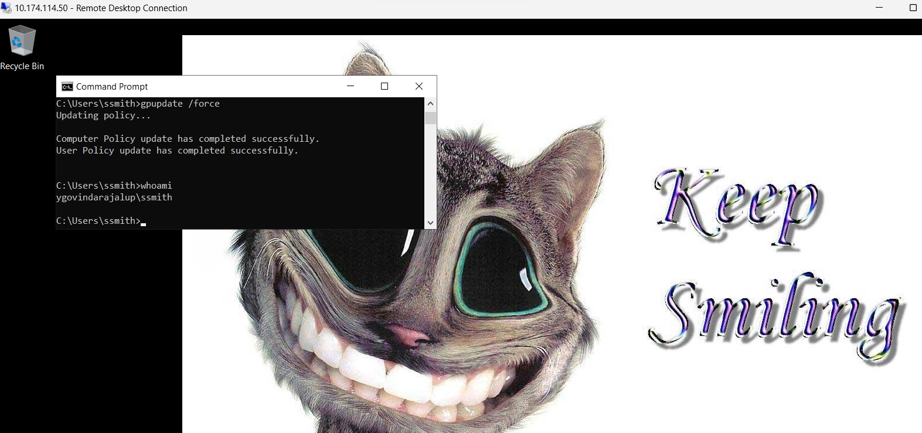

Creating a New GPO (Kitty)

I created a new GPO named "Kitty" in this screenshot and linked it to the domain. The desktop wallpaper policy was configured to map to the "Cat.jpg" file. After forcing a group policy update and logging out of the Windows Server VM, I observed the expected wallpaper change for the "Smith" account, reflecting the policy set in the "Kitty" GPO.

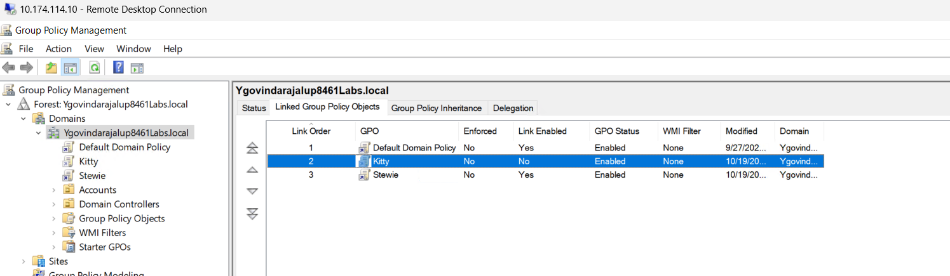

Reversing GPO Processing Order

In this screenshot, I reversed the processing order of the "Stewie" and "Kitty" GPOs. After forcing a group policy update and logging out of the Windows Server VM, I noted the expected wallpaper for the "Smith" account, which reflects the updated order of GPO processing.

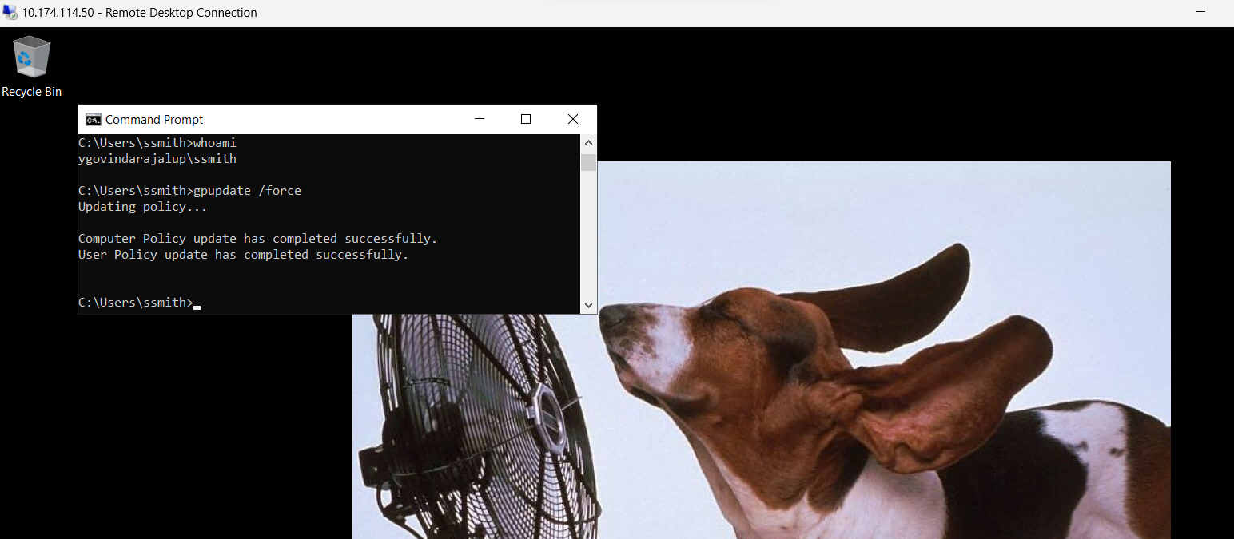

Creating a New GPO (Puppy)

I created a new GPO named "Puppy" in this screenshot and linked it to the "Employees OU." The desktop wallpaper policy was configured to map to the "Dog.jpg" file. After forcing a group policy update and logging out of the Windows Server VM, I observed the expected wallpaper change for the "Smith" account, reflecting the policy set in the "Puppy" GPO.

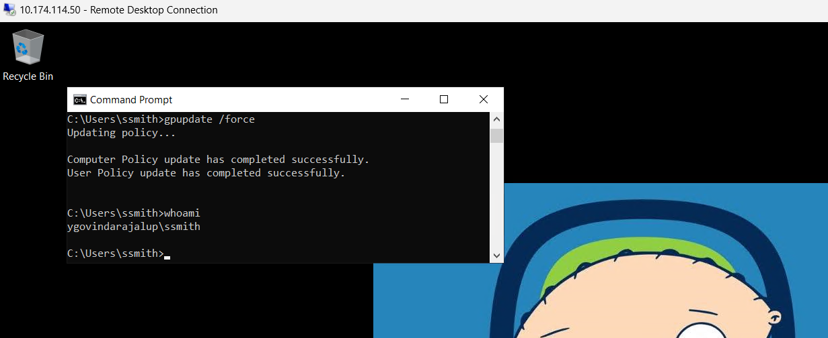

Modifying Security Filtering and GPO Links

Here, I deleted the link to the "Dog" GPO on the "Employees OU." I also modified security filtering on the "Stewie" GPO to ensure it is only processed by the "G_Ops_Staff" group and similarly modified the "Cat" GPO to be processed by the "G_HR_Staff" group. After forcing a group policy update and logging out of the Windows Server VM, I observed the expected wallpapers for the "Smith" and "Jones" accounts, reflecting the security filtering and GPO configurations.

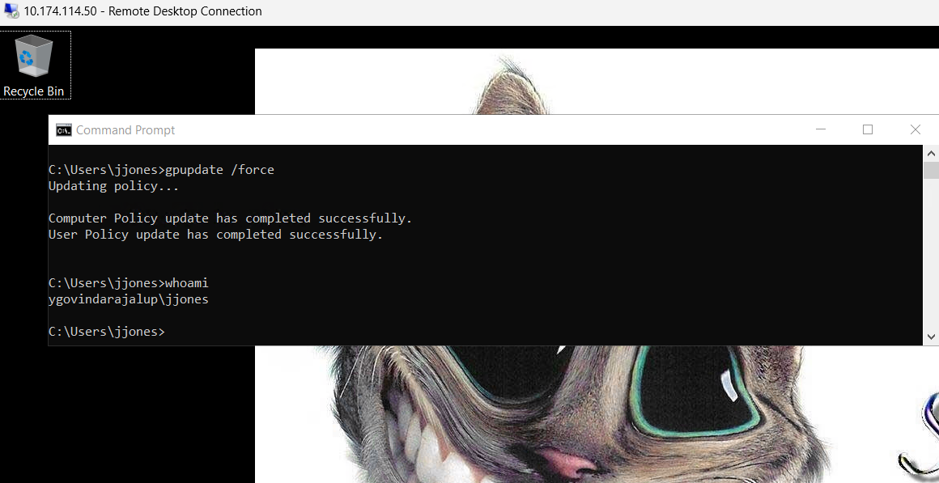

Modifying Security Filtering and GPO Links

Jjones wallpaper screenshot is displayed above.

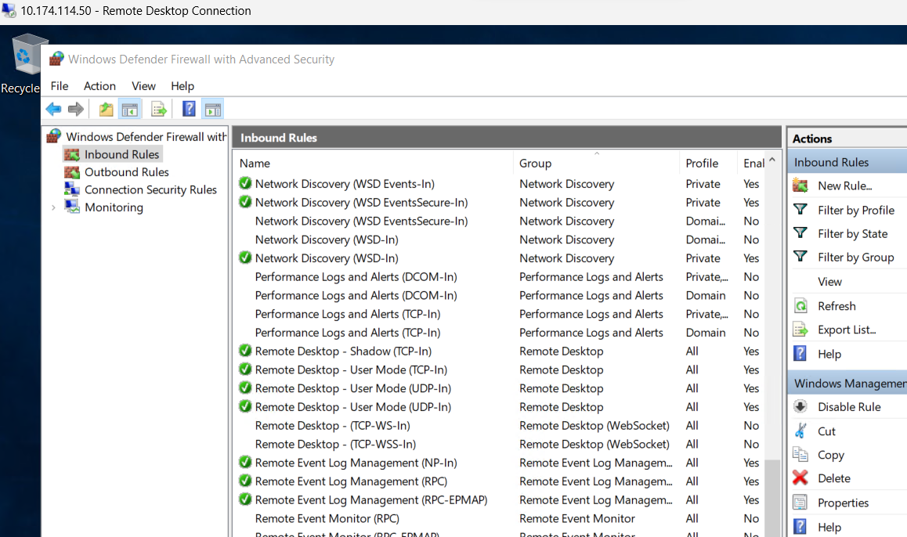

Configuring Firewall for Policy Results Reporting

In this screenshot, I logged on to the Windows Server VM with the administrator account and configured the firewall to allow policy results reporting. I enabled specific rules, including "Remote Event Management (NP-In)," "Remote Event Management (RPC)," "Remote Event Management (RPC-EPMAP)," and "Windows Management Instrumentation (WMI-In)."

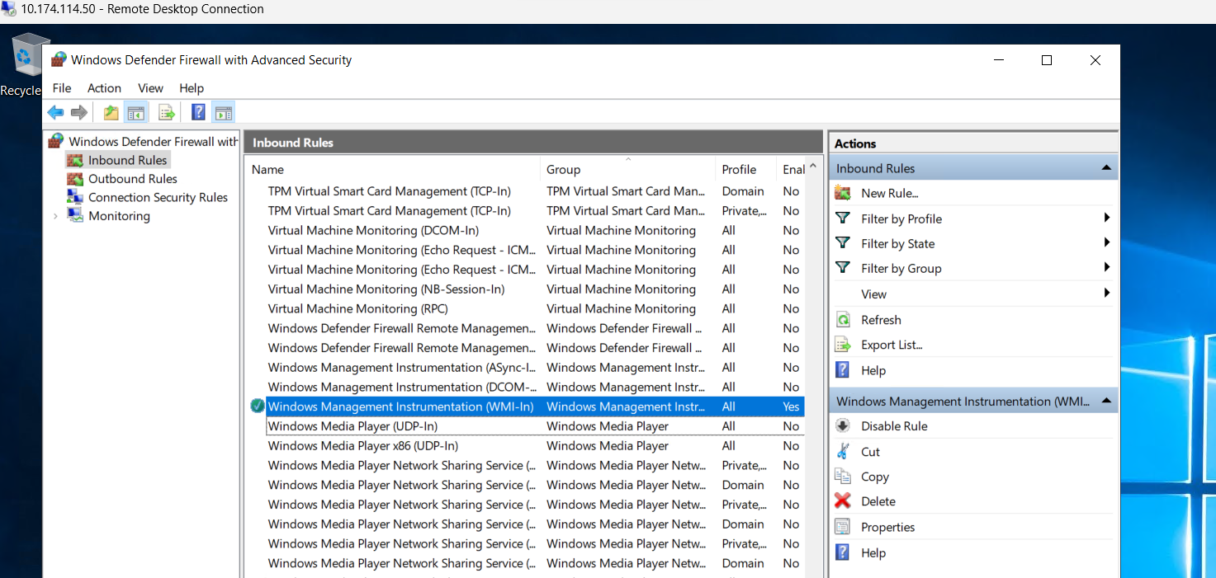

This screenshot displays configuring Firewall for Policy Results Reporting Screenshot.

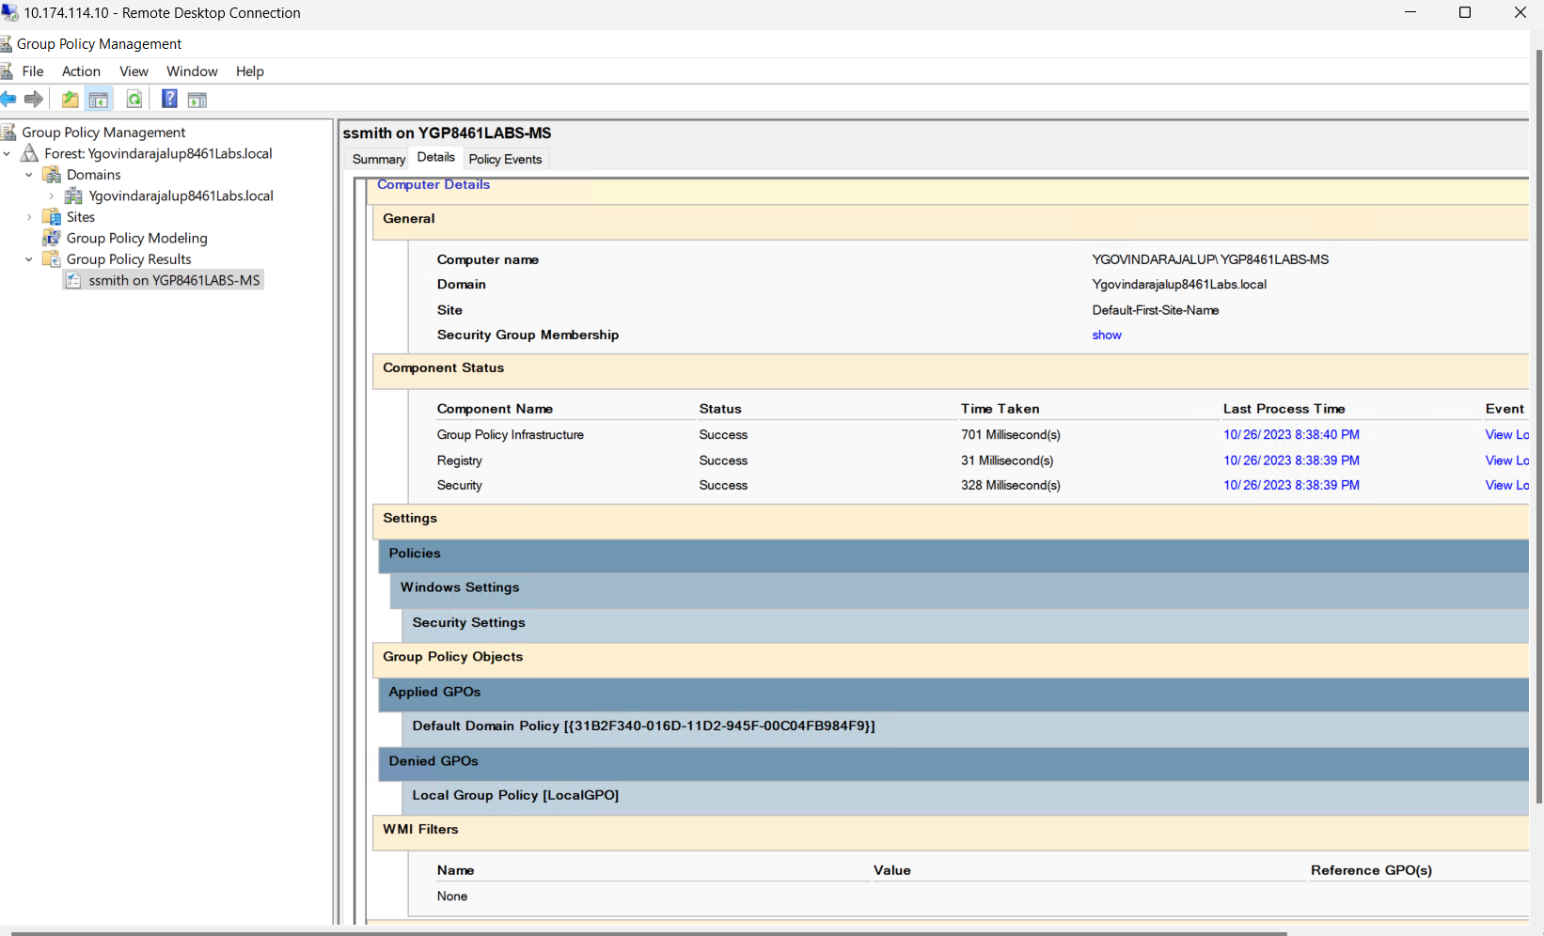

Changing Security Filtering and Executing GPO Results Wizard

Here, I changed the security filtering on the "Stewie" and "Cat" GPOs so that both are processed by "Authenticated Users." I executed the Group Policy Results Wizard, selected the MS computer, and the "Smith" account. I scanned what was applied and what was not for the computer and user. I also observed events related to group policy processing.

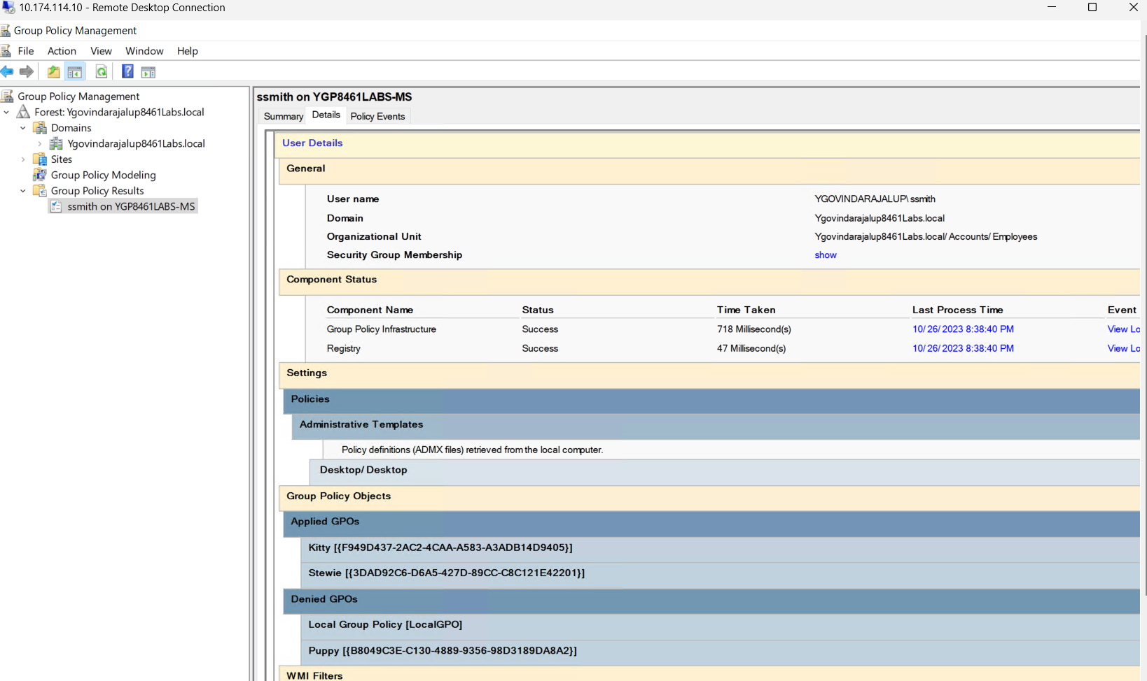

This Screenshot displays what was scanned for both the computer and the user. For the

user, these GPOs were applied, and these were not. For the user, these

policies were applied, but these were not.

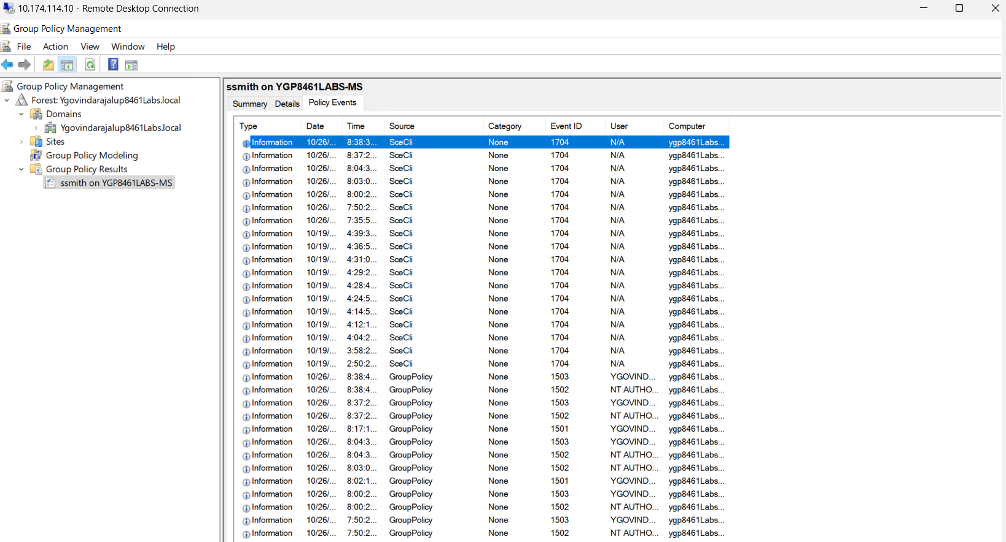

This screenshot displays the events that are related to group policy processing.

File System Permissions:

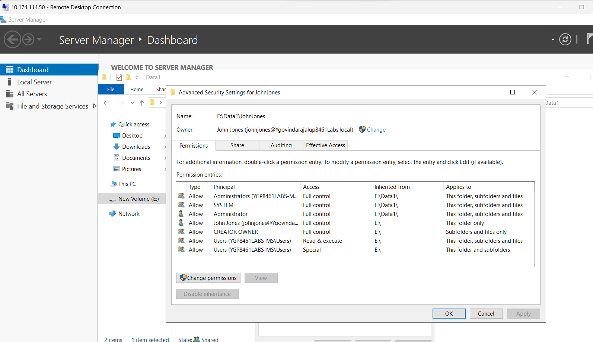

Reviewing NTFS Permissions for the John Jones Folder.

This screenshot reviews the NTFS permissions for the "Data1" folder. It instructs you to open the properties of "E:\Data1," view the default permissions, access rights for security principals, and advanced permissions. It also guides you to observe the Advanced Security Settings and the Access Control Entry (ACE) for "Users Read and Execute."

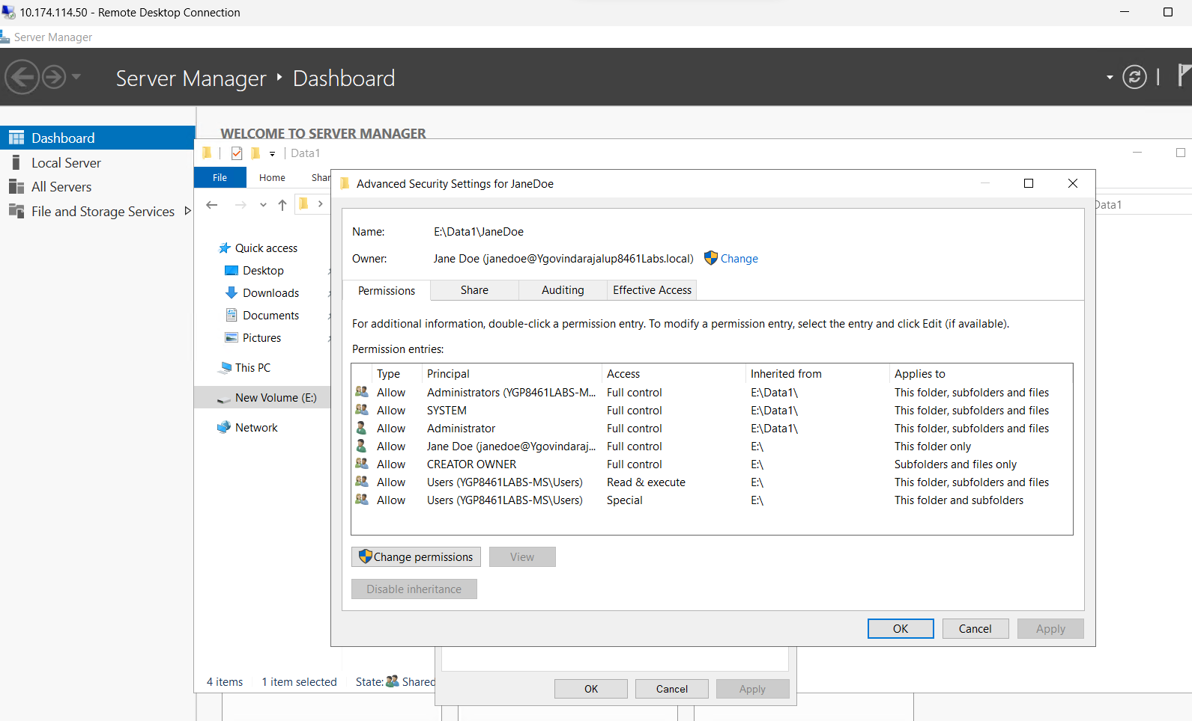

This Screenshot continues to show the NTFS permissions for the Jane Doe folder.

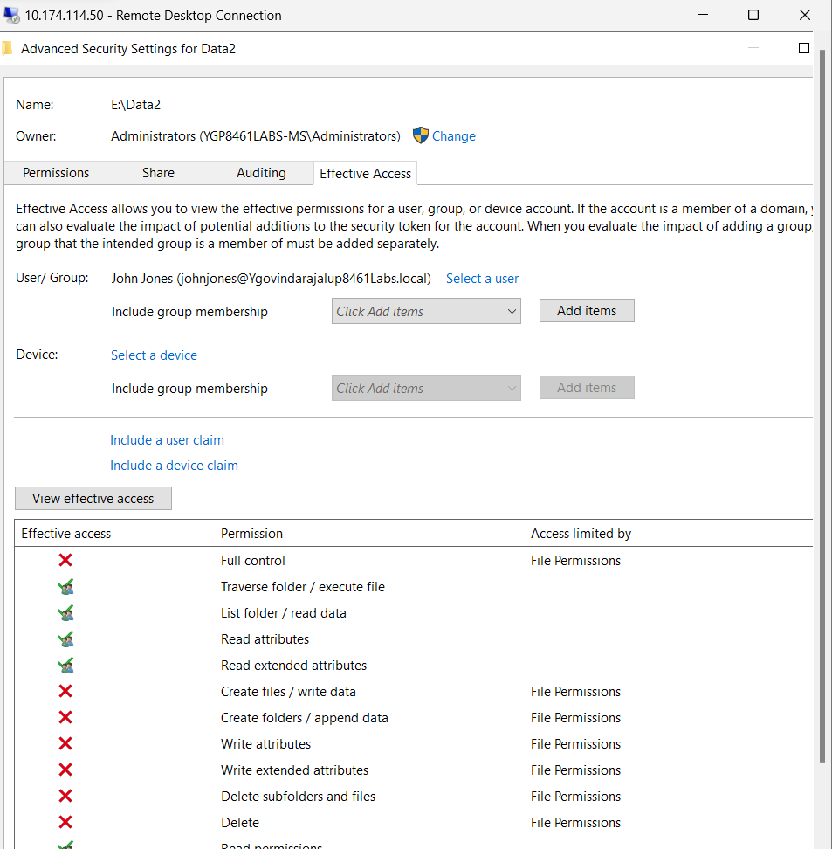

This screenshot displays John Jones's adequate access.

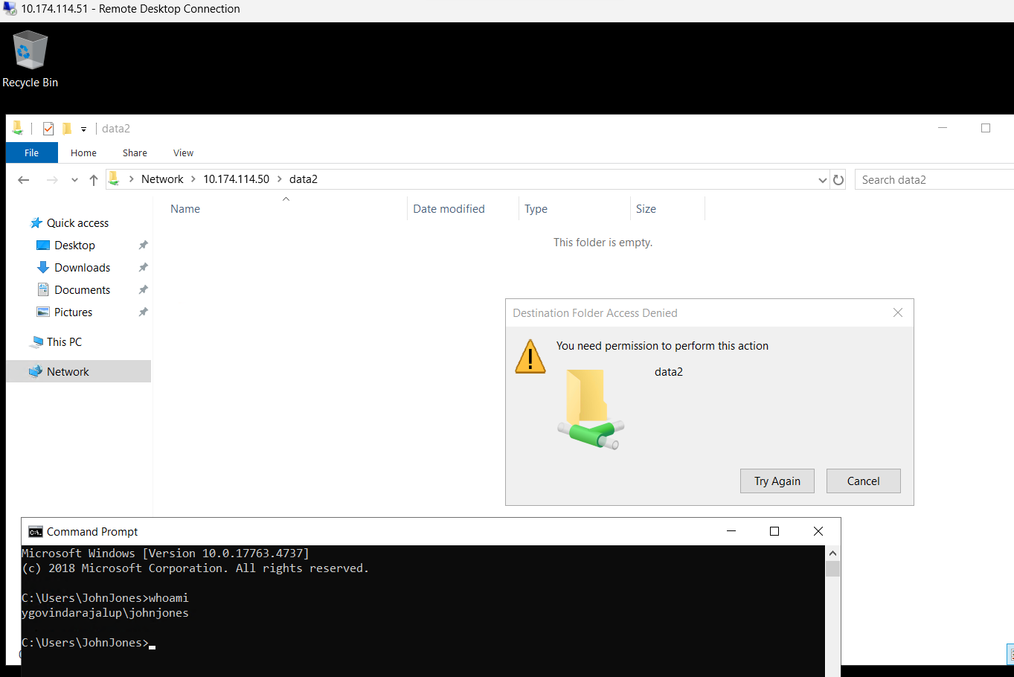

Testing Data2 Shares with John Jones

This screenshot involves testing the Data2 share from a client's perspective. Log in with the client using the John Jones account, navigate to the Data2 share, and try creating a text file and a folder. The outcomes of these actions are recorded.

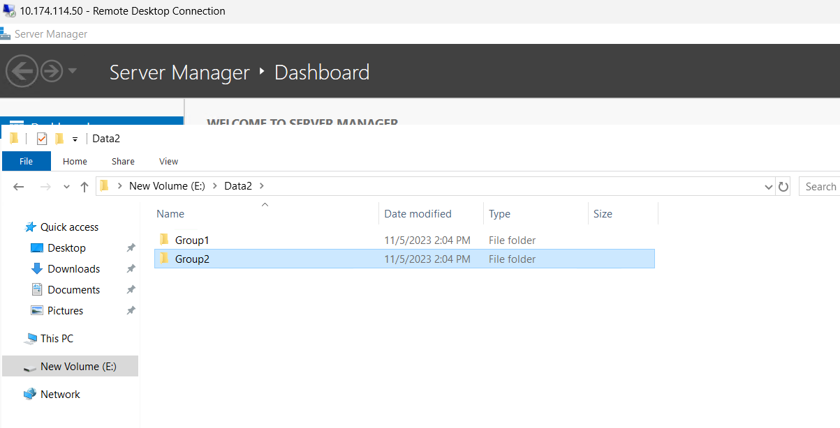

This screenshot displays the Data 2 accessed after the advanced security properties for Data2, selecting the Deny ACE button.



This screenshot displays after turning off inheritance and selecting Convert inherited.

Permissions and selecting the Allow, Users, Special ACE and removing it successfully.

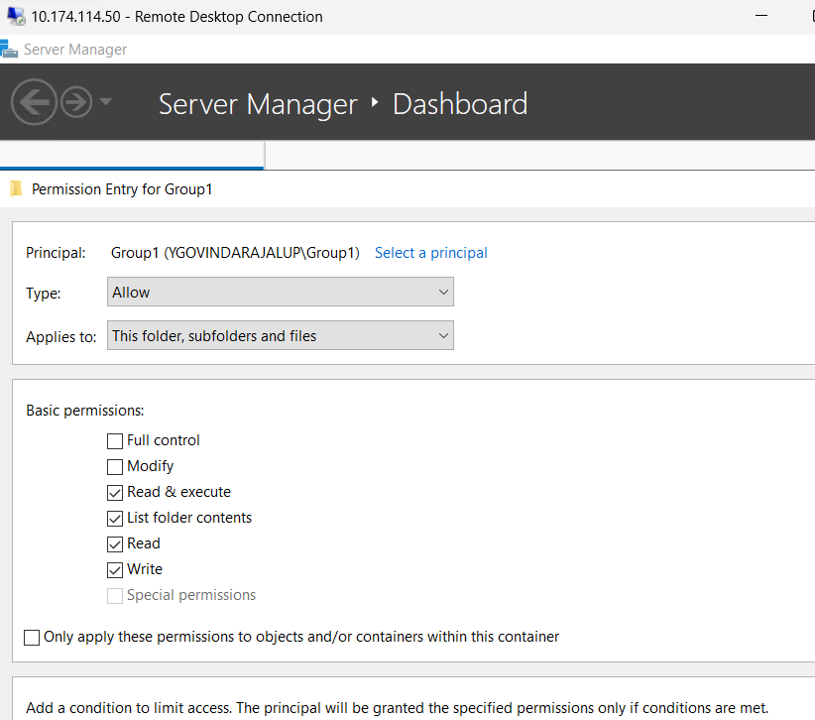

This Screenshot displays the creation of a new principle, “Group1”.

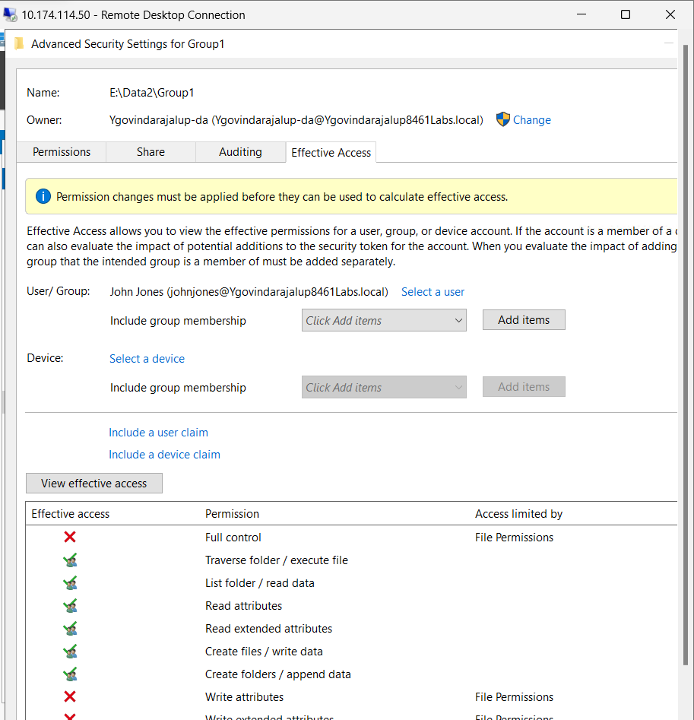

This displays John Jones' adequate access.

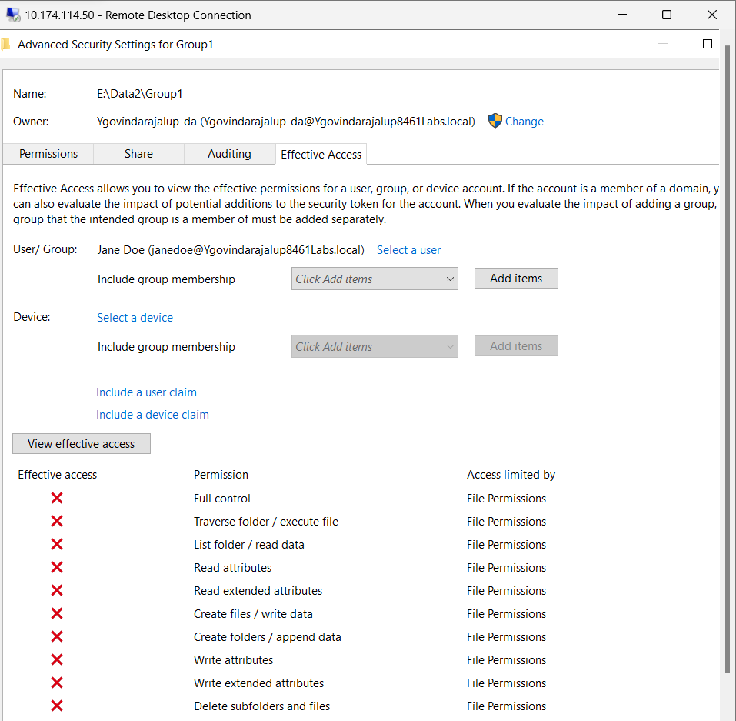

This displays Jane Doe's adequate access.

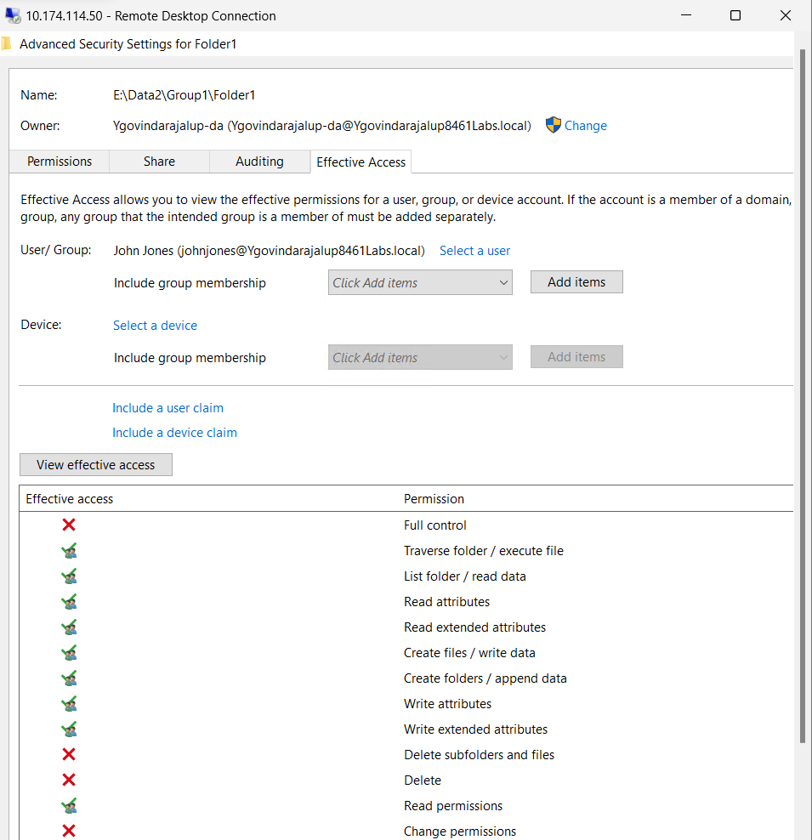

This screenshot displays the difference between Inherited and the ACE created in the previous step.

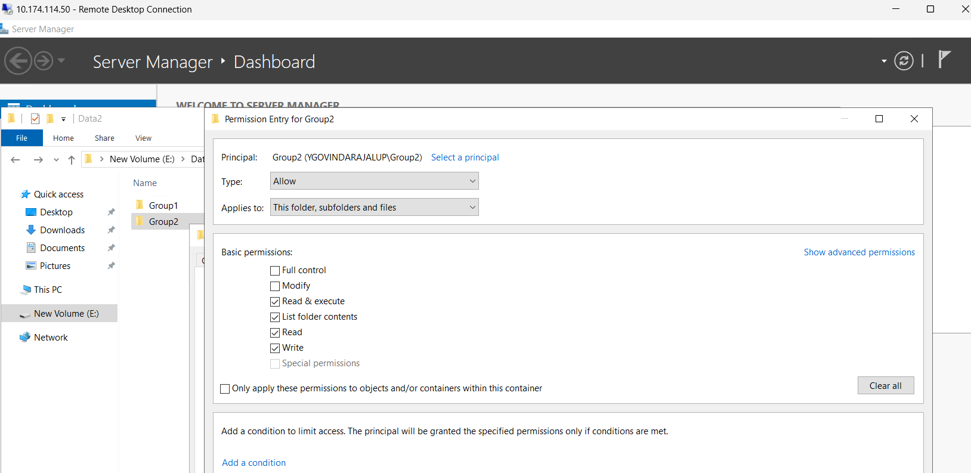

This Screenshot displays the creation of a new principle, “Group2”.

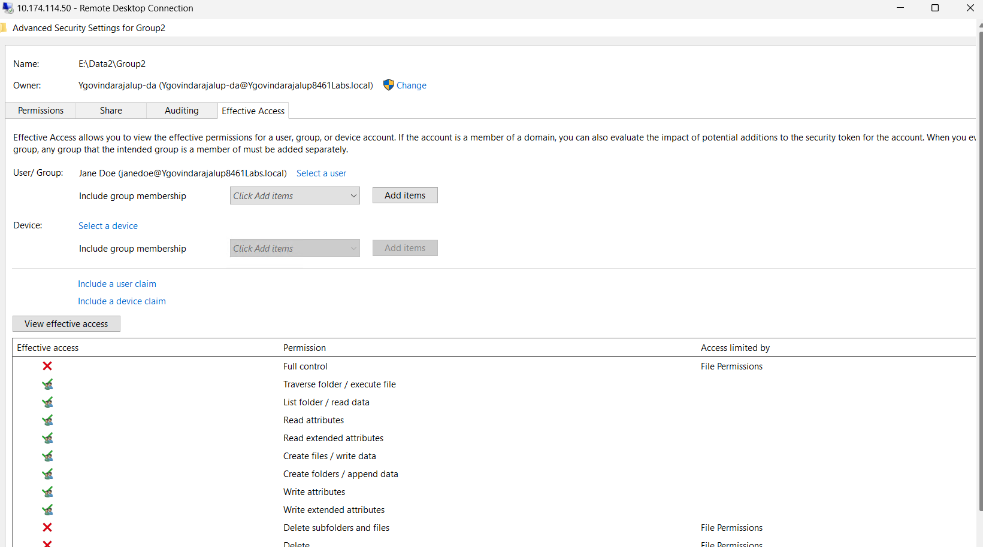

This displays Jane Doe's adequate access after creating the Group 2 principal.

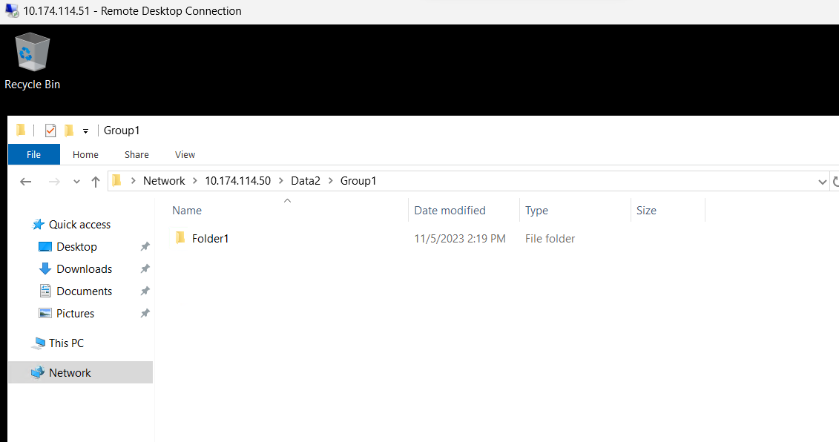

This screenshot displays the client VM accessing the Data2\ Group1 folder.

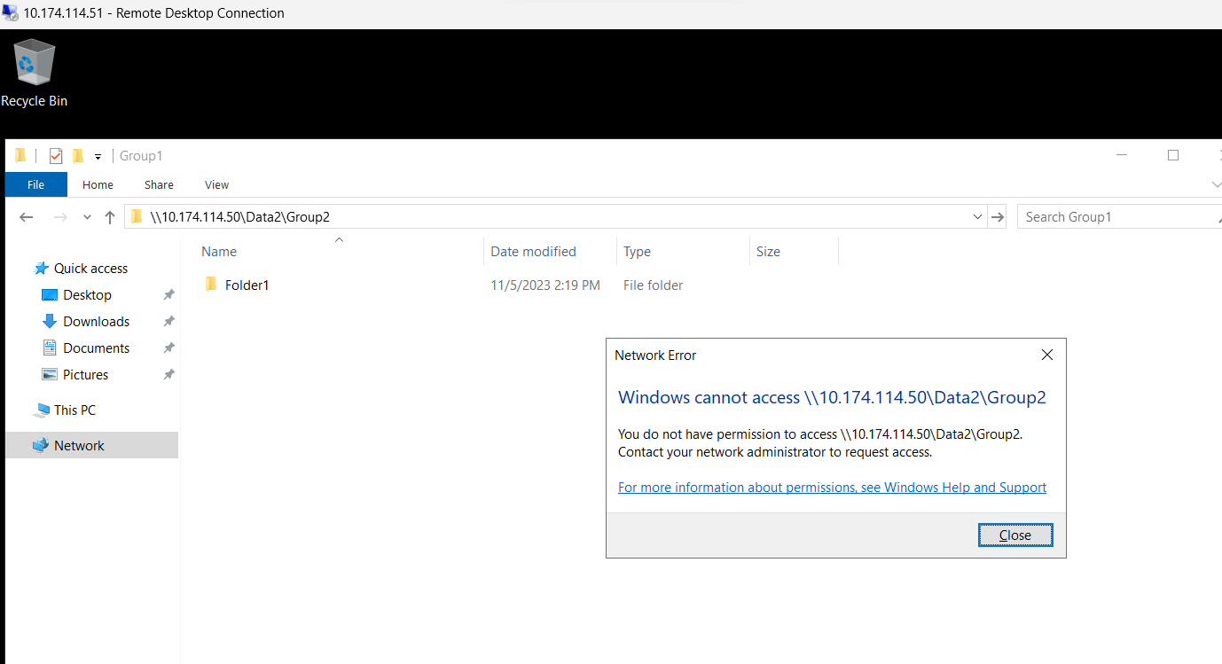

This screenshot displays the client VM’s inability to access the Data2\ Group2 folder.

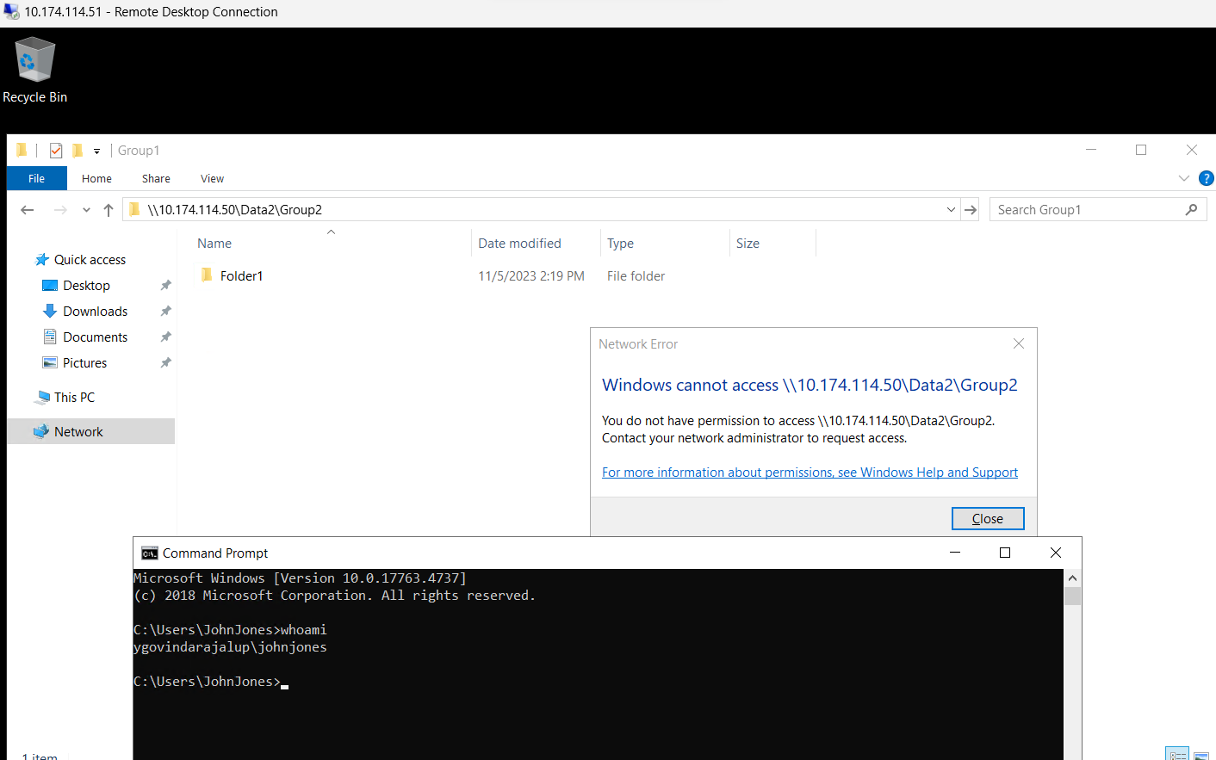

This screenshot shows the successful error that should occur in the 14th step.

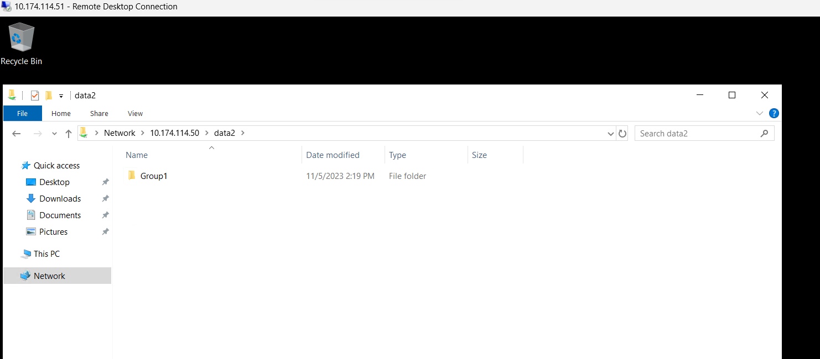

This screenshot proves that John will only be able to see Group 1.

Configuring Permissions using RBAC on Publications:

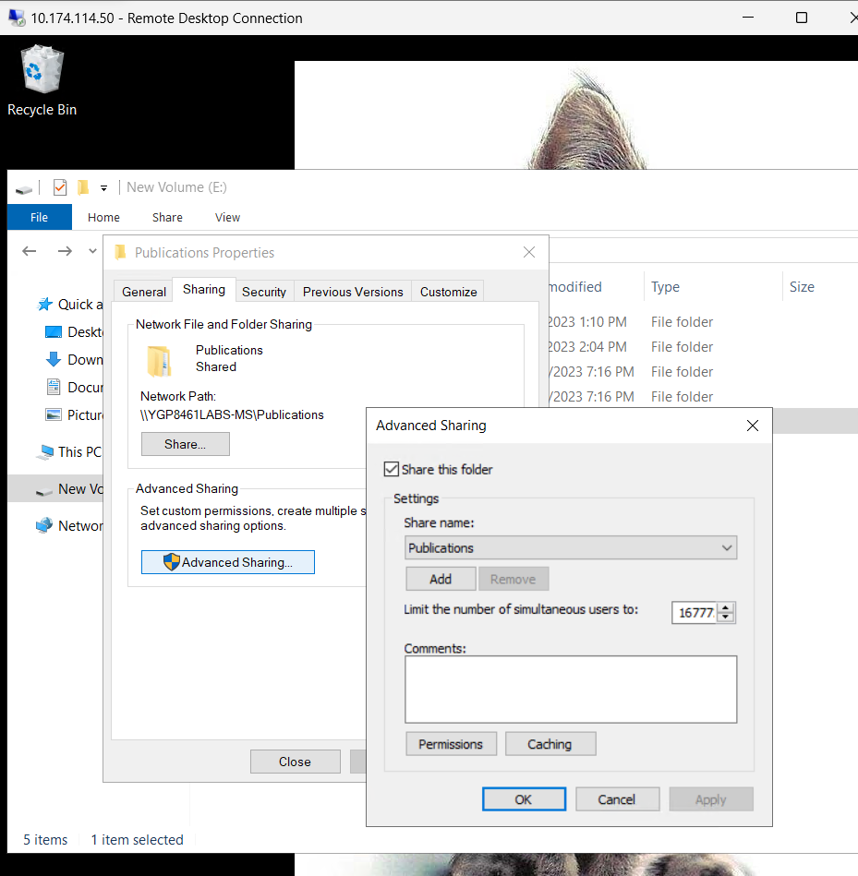

Creating Publications Folders

This screenshot captures the creation of departmental folders within the "Publications" directory on the E: drive. Two subdirectories, "HR" and "Operations," are established. It also mentions that share permissions should be configured following best practices from previous labs and instructs to note the configuration settings.

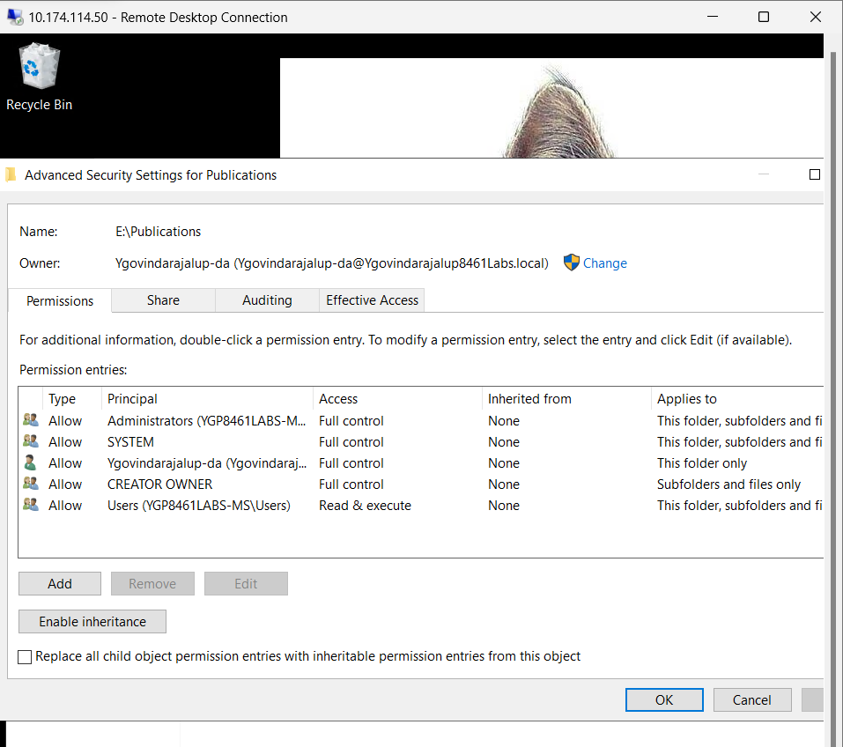

Turning off Inheritance on Publications Folder

In this screenshot, inheritance is turned off in the "Publications" folder. While keeping most NTFS Access Control Entries (ACEs) intact, the screenshot advises disabling the ACE allowing all users to create content within the directory. You are instructed to document the expected access for standard users to that folder, check effective permissions, and compare them to your expectations. Additionally, the ACE responsible for granting access is to be identified.

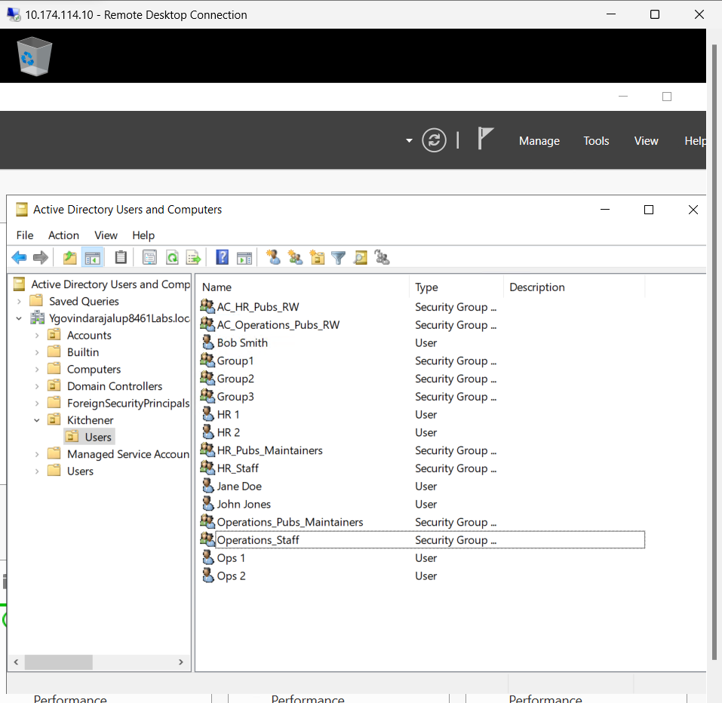

Creating Users and Groups on the Domain Controller

This screenshot shifts the focus to the domain controller, where users and groups are created to be used as security principals in the Kitchener/Users OU. Several groups, including "HR_Staff" and "Operations_Staff," are made, along with two users for each department. Additionally, groups like "HR_Pubs_Maintainers" and "AC_HR_Pubs_RW" are established. The purpose and roles of these groups are highlighted.

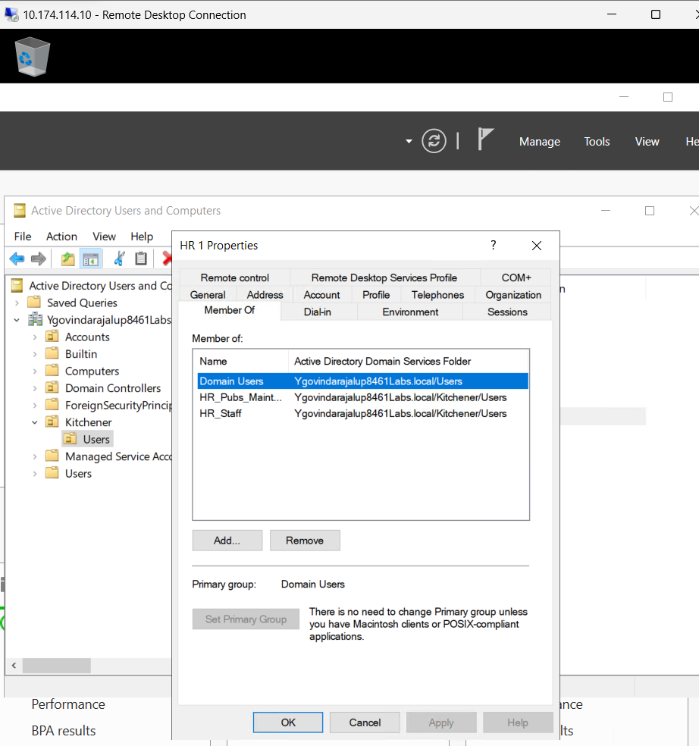

Group Membership Setup for HR1.

This screenshot elaborates on group membership setup, where HR users are added to the "HR_Staff" group, Operations users are added to the "Operations_Staff" group, and one HR user becomes a member of the "HR_Pubs_Maintainer" group. One Operations user joins the "Operations_Pubs_Maintainer" group. The achieved group hierarchy and roles are explained.

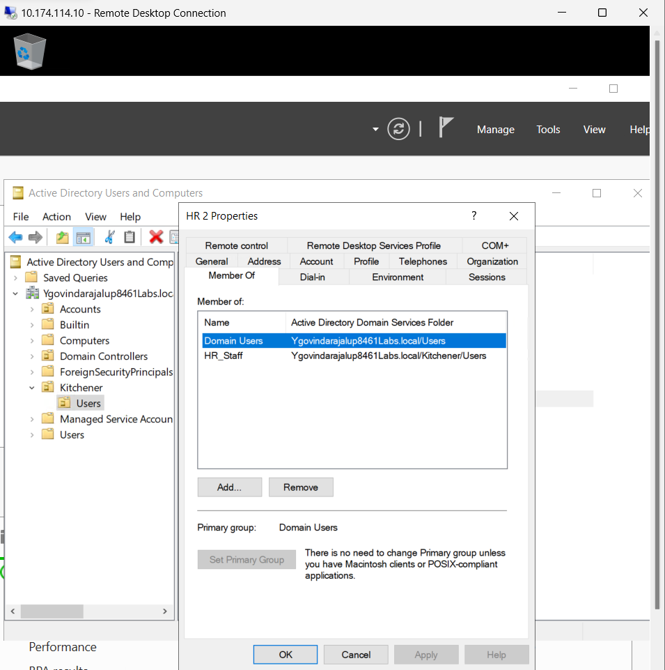

Group Membership Setup Screenshot for HR2.

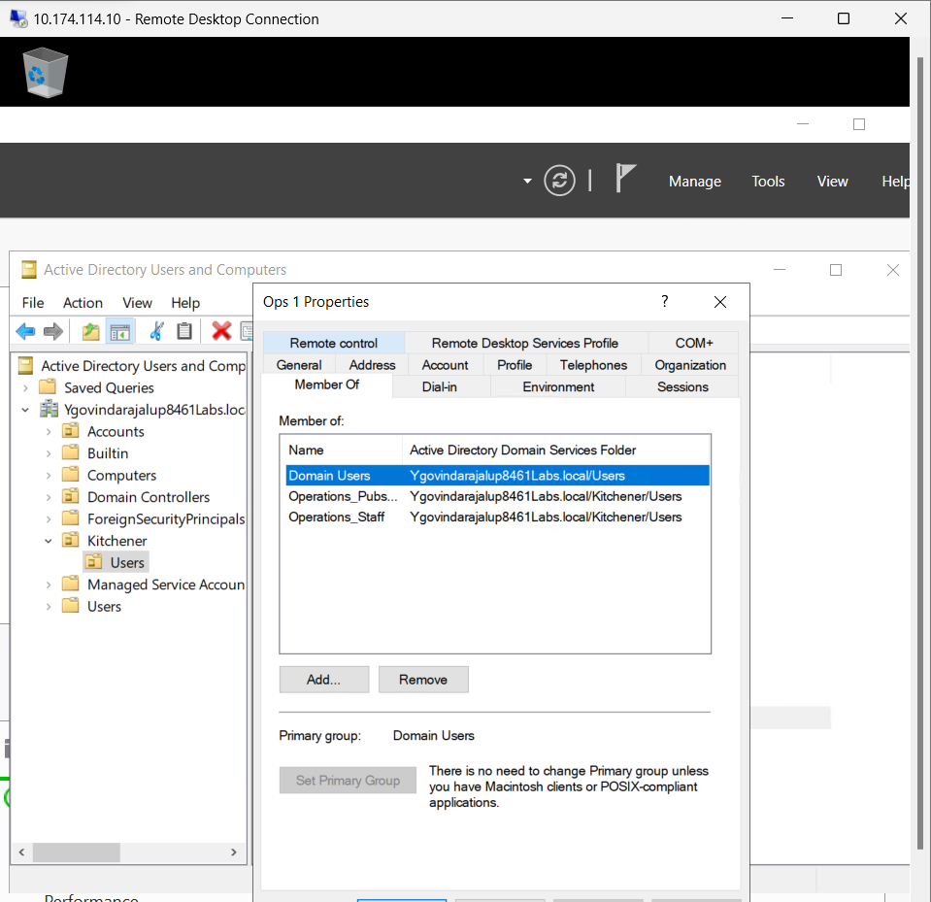

Group Membership Setup for OPS1.

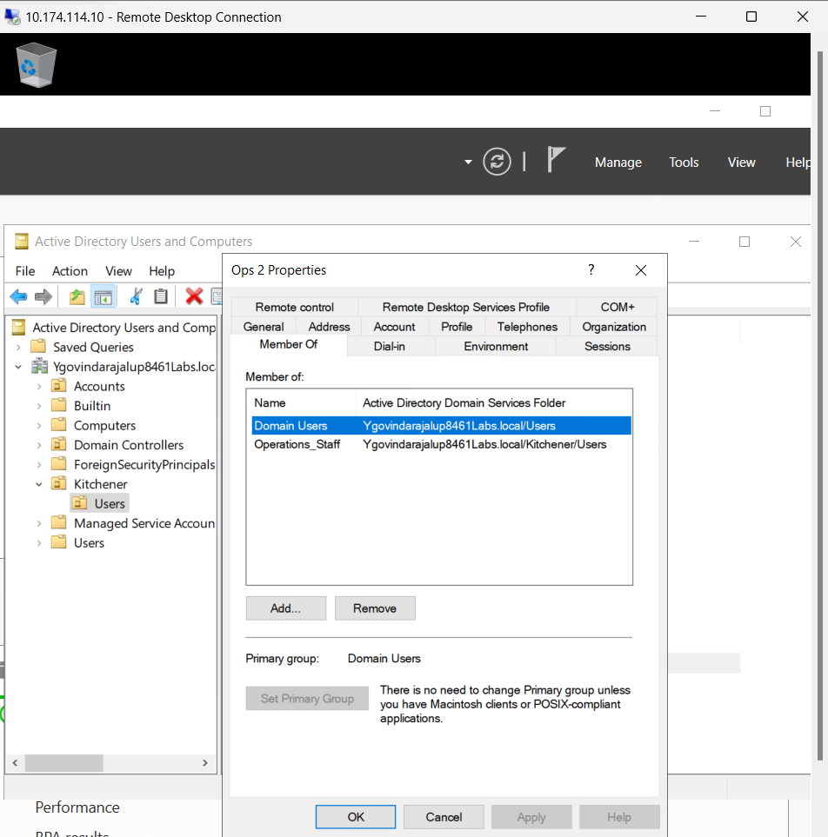

Group Membership Setup for OPS2.

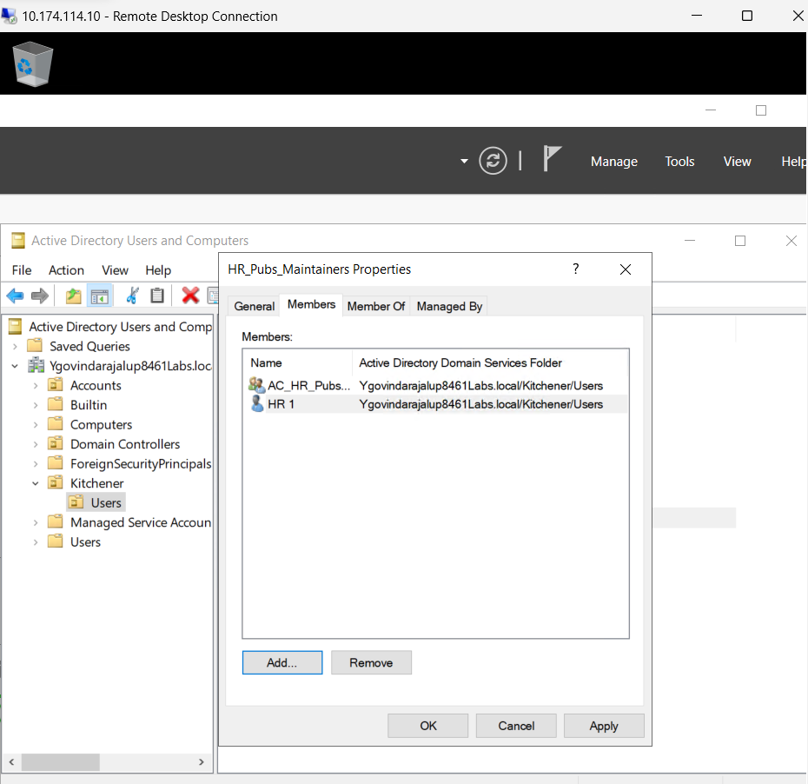

Establishing Relationships with RBAC

This screenshot establishes relationships between groups, explicitly making the "HR_Pubs_Maintainer" group a member of the "AC_HR_Pubs_RW" group, and similarly for the Operations department. The concept of Role-Based Access Control (RBAC) and the achieved role relationships are emphasized.

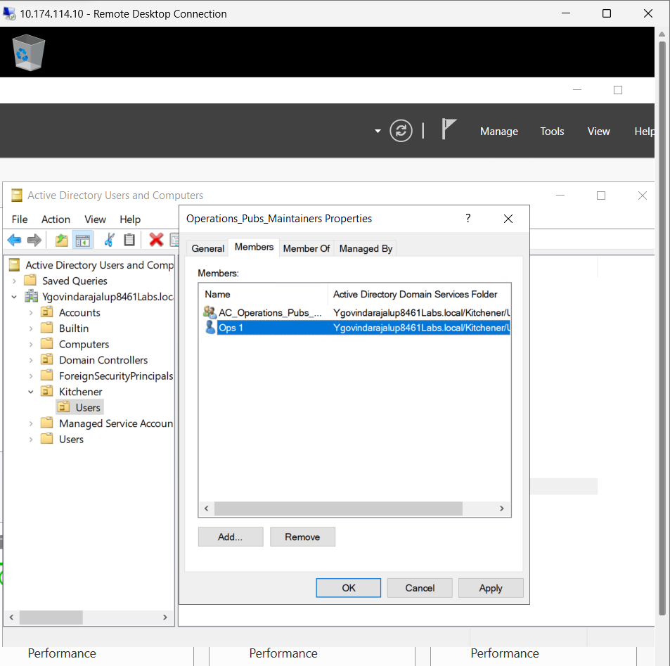

In terms of RBAC, what did you achieve?

The following Observation was made :   
There is no inheritance in publications; Inheritance in HR is enabled.

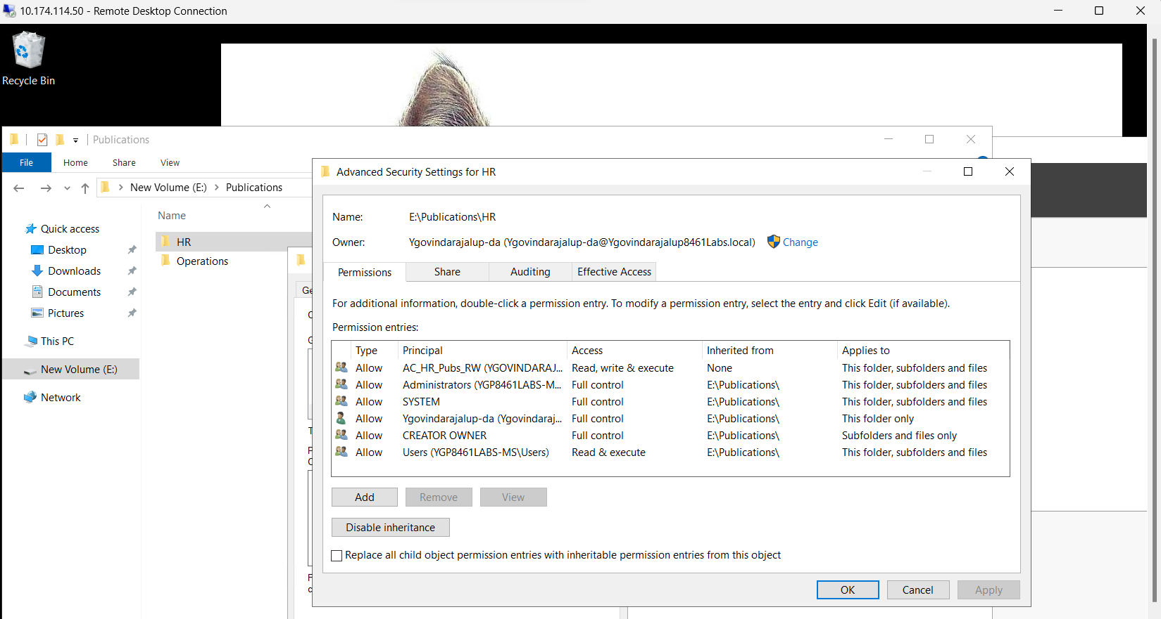

Configuring Permissions on HR and Operations Folders

This screenshot displays configuring permissions using RBAC on department-specific folders. It instructs you to create an ACE on the "Publications\HR" folder, granting Read, Write, and Execute permissions to the "AC_HR_Pubs_RW" group. A similar ACE is to be created for the "Publications\Operations" folder. The focus is on ensuring proper access for respective department users.

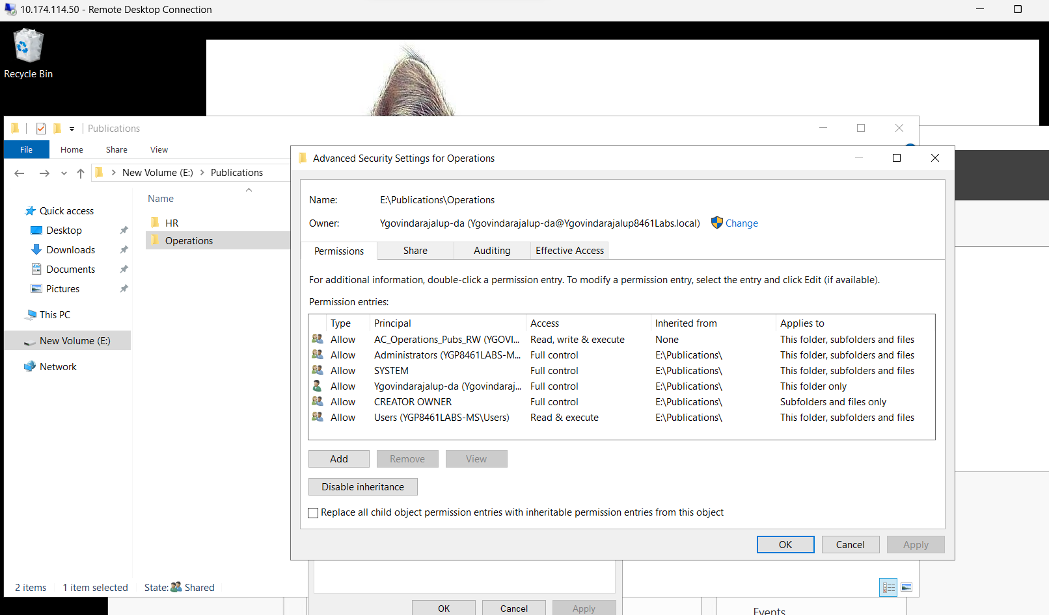

Configure Permissions Using RBAC on Team Folders:

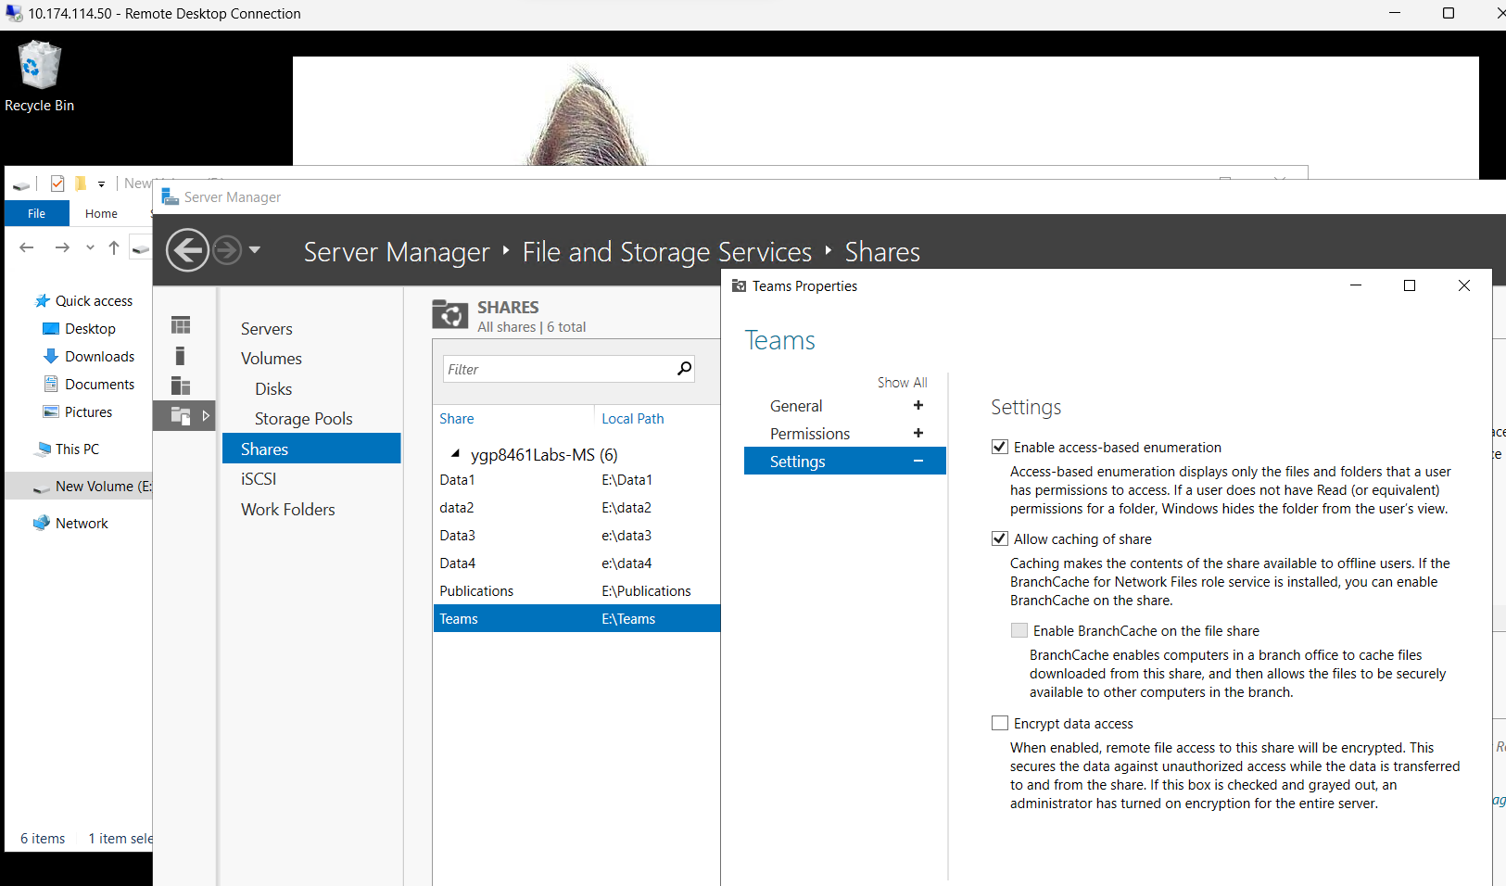

Configuring Permissions on Team Folders

In this screenshot, you create a " Teams " folder on the E: drive and establish HR and Operations folders underneath. The "Teams" folder is shared, Access-Based Enumeration (ABE) is enabled, and share permissions are configured. Configuration settings are to be documented.

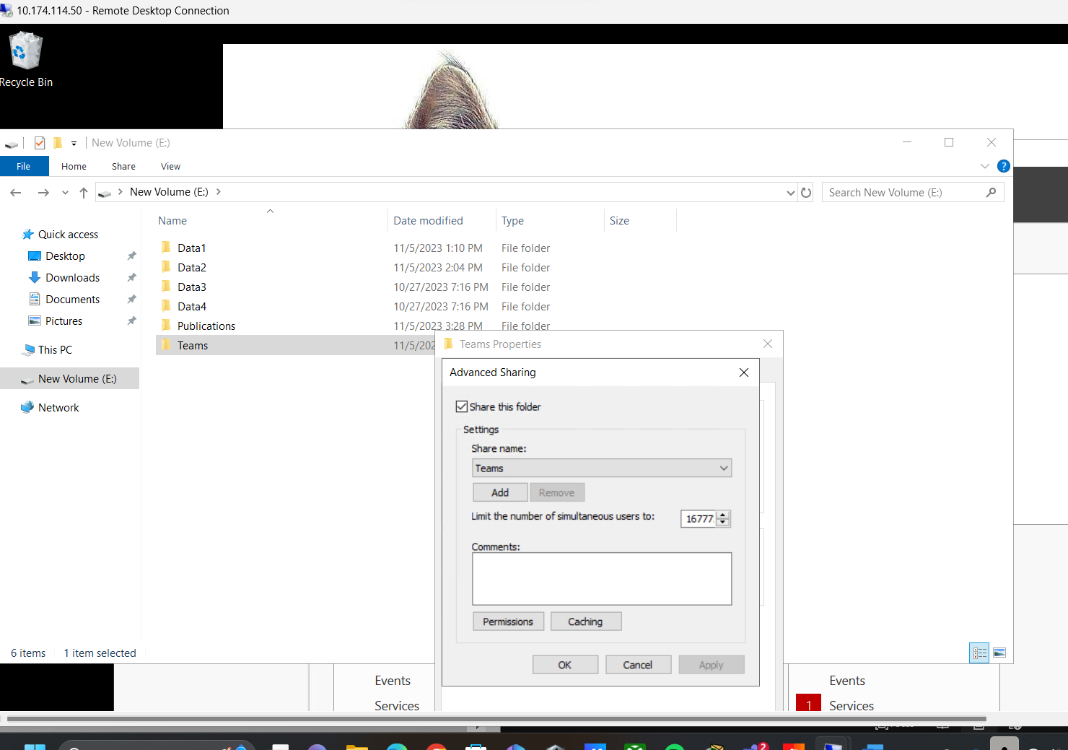

This screenshot displays the Advanced Sharing Details for the Teams folder.

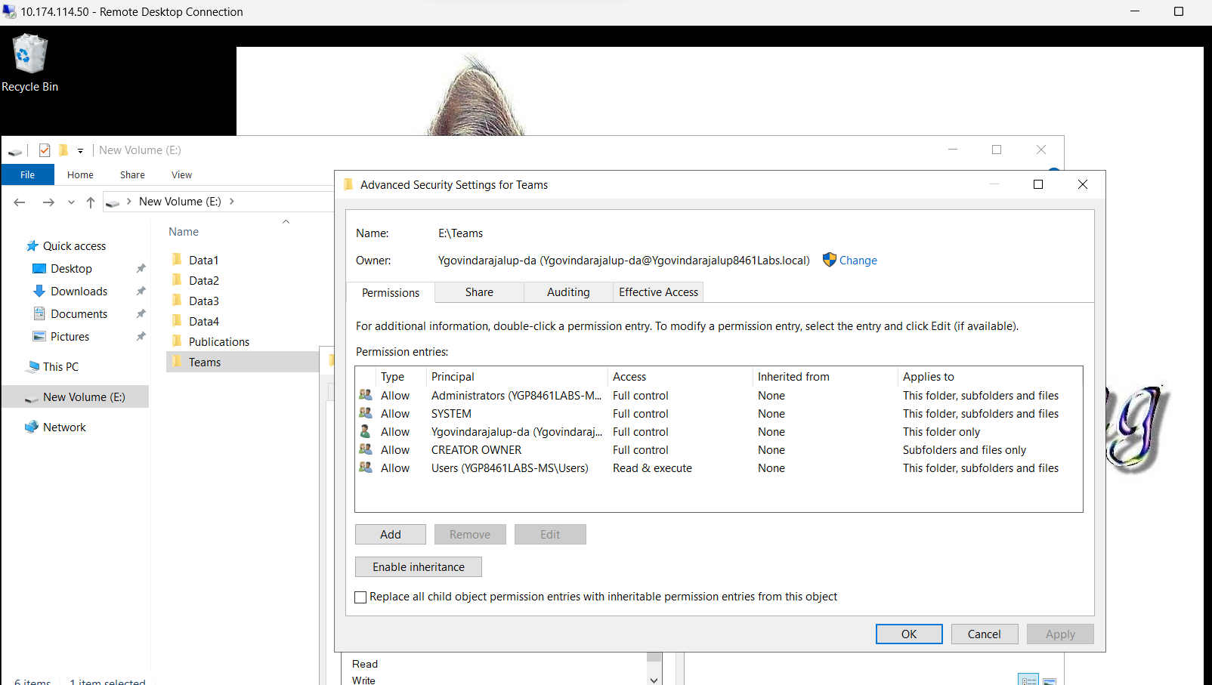

Turning off Inheritance on Teams Share

This screenshot focuses on disabling inheritance on the "Teams" share while preserving most NTFS ACEs, except for the one granting all users the ability to create content. Notably, the screenshot specifies adjusting the ACE, allowing all users to read content by limiting its scope to "This folder only."

NTFS Permission Inheritance (Jim Dickson, 2019, 0:00

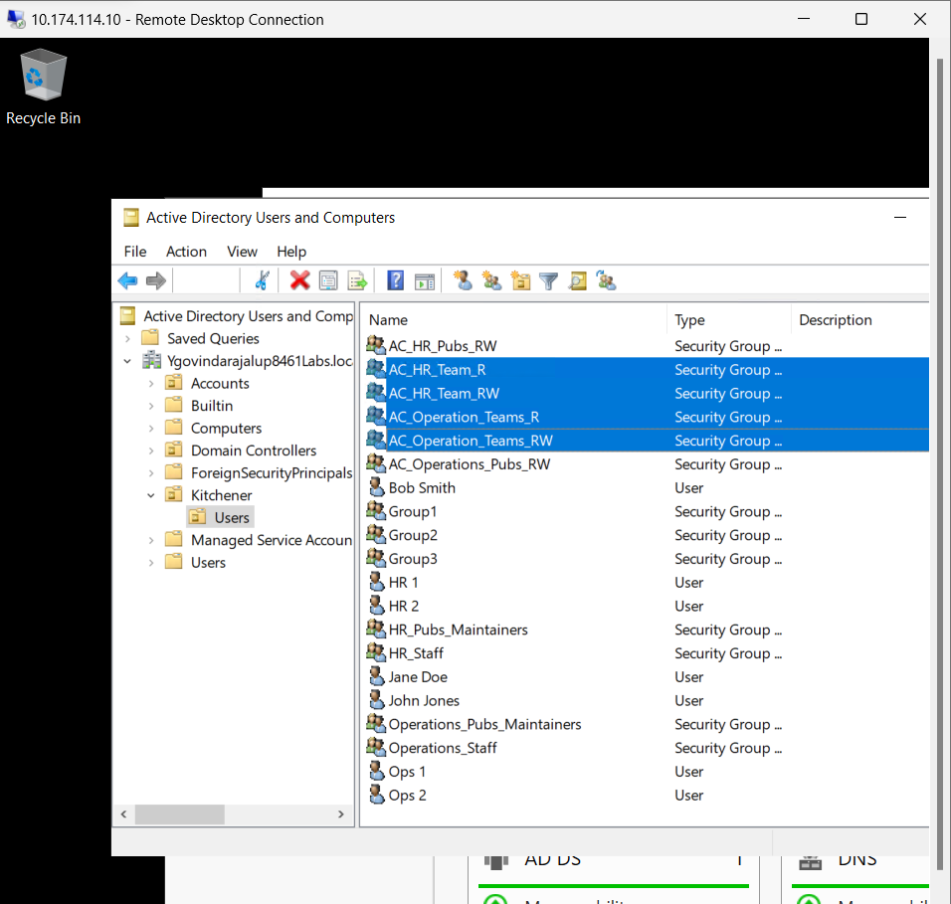

Creating Groups on the Domain Controller

This screenshot shifts attention to the domain controller, where groups are created as security principals in the Kitchener/Users OU. It mentions specific groups such as "AC_HR_Team_R" and "AC_HR_Team_RW" and elaborates on their intended use.

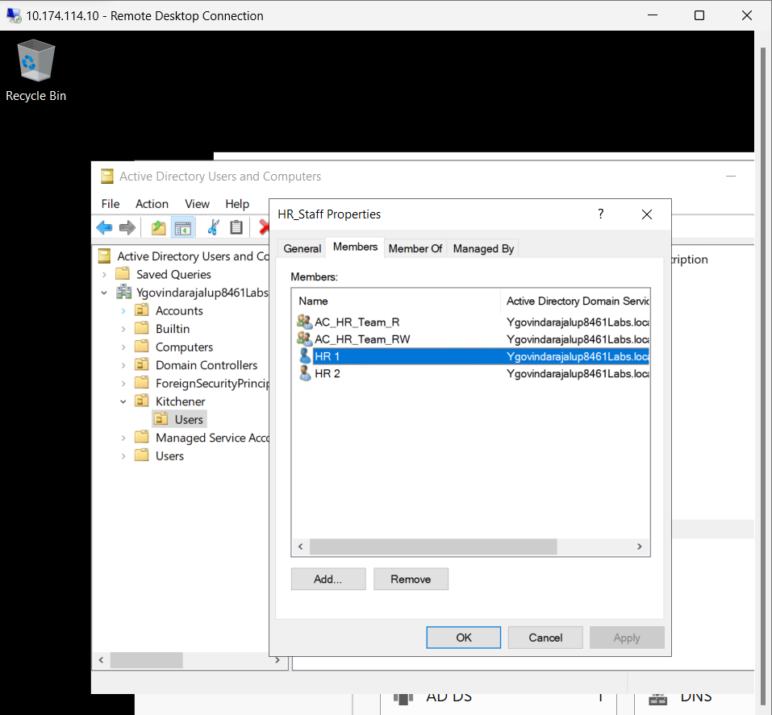

Group Membership and ACE Configuration

Here, you make HR and Operations staff members of the "AC_HR_Team_R" and "AC_HR_Team_RW" groups, establishing role relationships. The focus is on configuring ACEs that govern access for team members.

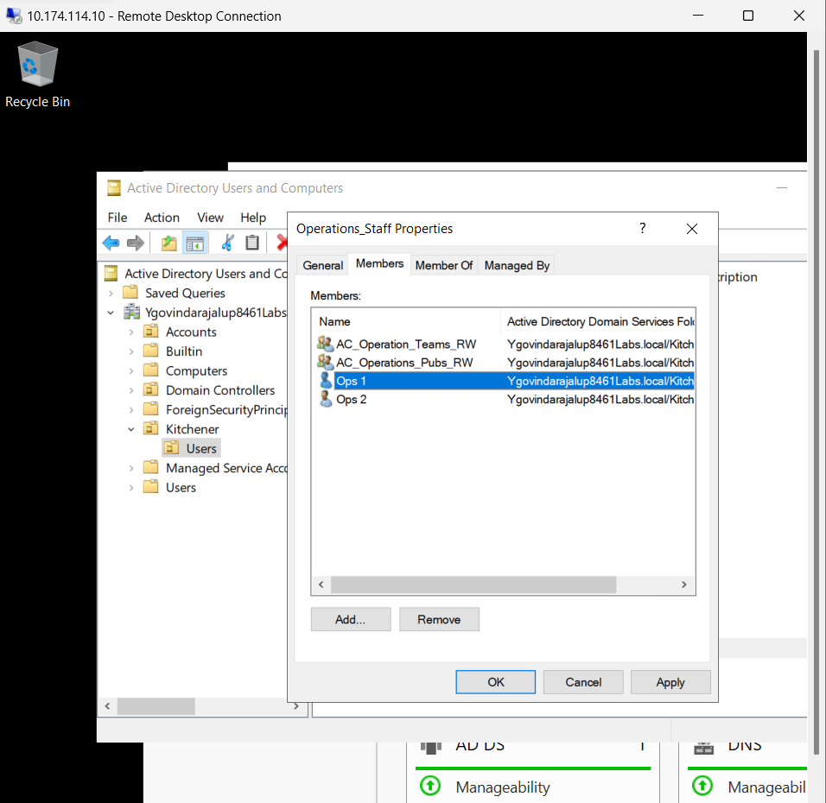

The screenshot displays the same as above for the operations_Staff folder.

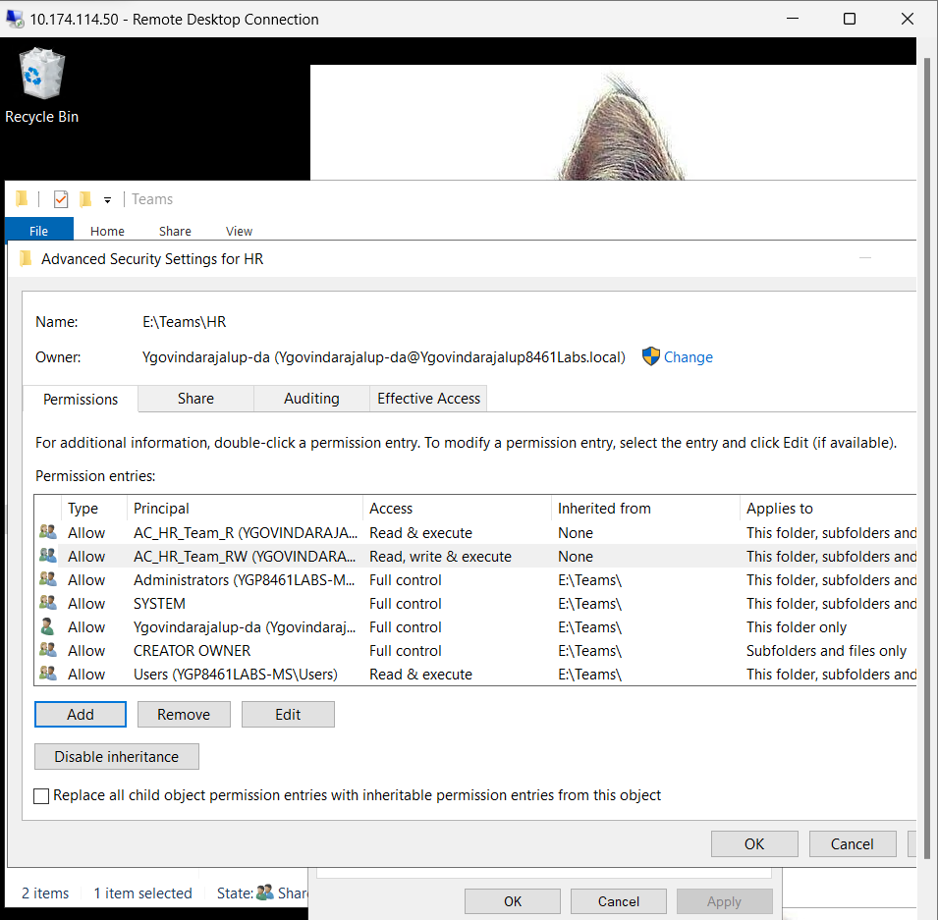

Expectations and Effective Permissions

This screenshot guides you to document your expectations regarding access for HR and Operations teams to their respective "Teams\HR" folder. After setting expectations, you assess the effective permissions and identify the responsible ACE for granting access.

NTFS Permissions and RBAC for a Publications Use Case(Jim Dickson, 2019, 0:00)

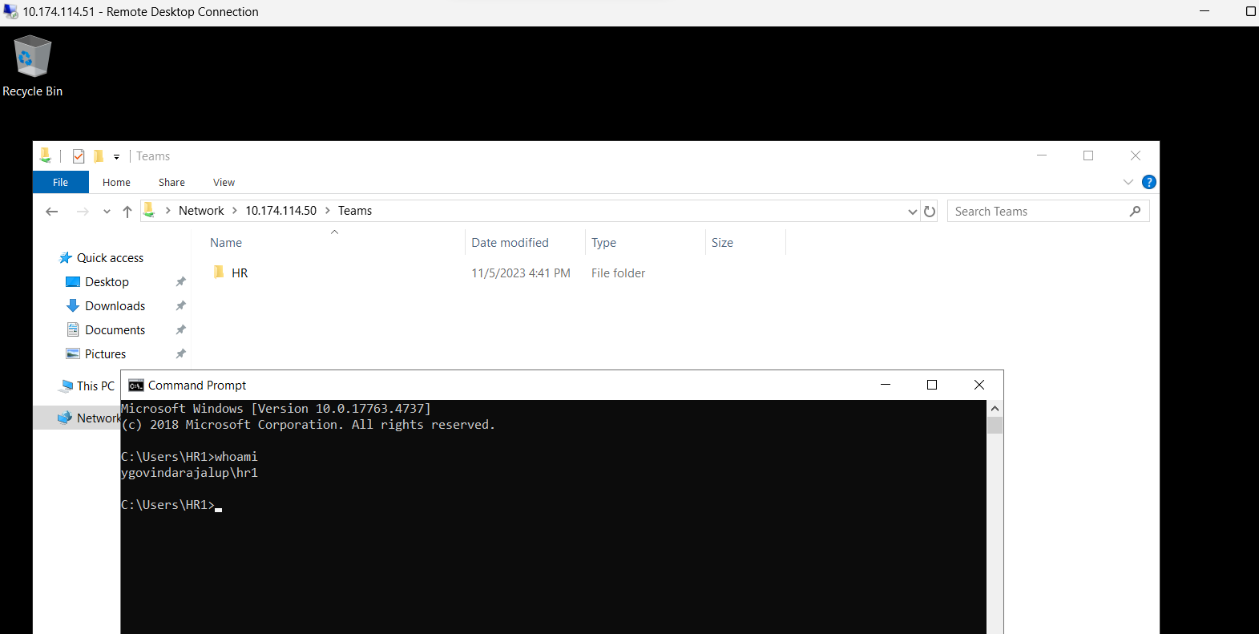

Testing Access for HR Team

In this screenshot, I logged in as a member of the HR team, navigated to the "Teams" share, and attempted to access content within the "Teams\HR" folder. The goal is to determine the accessibility of content for team members.

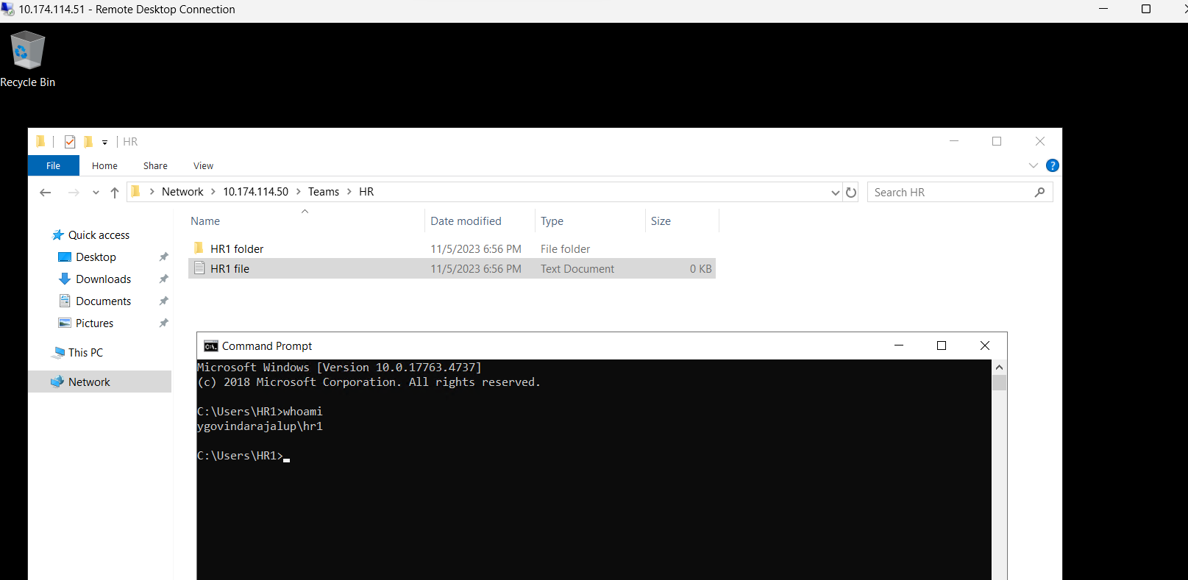

This Screenshot displays the successful access of the HR folder by the HR1 user in the client VM.

NTFS Permissions and RBAC for a Teams Use Case (Jim Dickson, 2019, 0:00)

## Reflection

The "Group Policy Exercise" opened my eyes to the power of Group Policy objects (GPOs) in simplifying the management of desktop configurations. It became apparent how GPOs can significantly impact the user experience, such as controlling desktop wallpaper settings. The various actions we took, including blocking GPO inheritance, enforcing GPO links, and reversing GPO processing order, illustrated the hierarchical nature of GPOs and the order in which they're applied.

Starting with the "File System Permissions Exercise," I had the opportunity to create users, groups, and folder structures while focusing on NTFS permissions. This part of the lab revealed that permissions could be more straightforward. Effective permissions turned out to be a combination of inherited and explicit settings, making it crucial to pay attention to both. Using "Allow" and "Deny" permissions, which can sometimes conflict, highlighted the importance of meticulous planning. Experimenting with breaking inheritance and exploring access-based enumeration (ABE) underscored the necessity of fine-grained control over permissions.

1. Read, list folder contents, and Read & Execute are the most basic permissions. Creating files/writing data and Creating folders/appending data are two exceptional file permissions.

John has complete control and access to all files. Domain users' basic permissions are not the same as John's permission. Domain users, on the other hand, have a different rule for special permission. Because John is a domain member, he has been assigned permissions.

2. John Jones has access to the Data1 sharing folder from the client system. In Data1, John can create a file and a folder.

3. Jane Doe can use the client system to visit the Datal share folder and view the files and folders created by John. Jane can create a new file and folder in Datal. Modifying the content of a file generated by John, on the other hand, is not permissible. Jane can create a file within the John folder.

Because John is the owner of the file, he has complete power. However, because Jane is a regular domain user, she will only have Read Execute permission for files, folders, and subfolders.

4. Users (YGP8461LABS-MS\Users) are the principle.

John Jones ([johnjones@Ygovindarajalup8461Labs.local](mailto:johnjones@Ygovindarajalup8461Labs.local))

5. Users (YGP8461LABS-MS\Users) is the principle.

John Jones ([johnjones@Ygovindarajalup8461Labs.local](mailto:johnjones@Ygovindarajalup8461Labs.local))

6. Special for folder- Users (YGP8461LABS-MS\Users)

Moving on to the "Configure Permissions Using RBAC on Publications" and "Configure Permissions Using RBAC on Team Folders" sections, I experienced firsthand how RBAC can be applied in real-world scenarios. These sections demonstrated the practical aspect of securing departmental and team resources efficiently. Creating nested groups and skillfully assigning permissions showcased how RBAC can help ensure users have the proper access while maintaining a robust security framework.

Reflecting on these exercises, I've gained a much deeper understanding of the complexities of RBAC and the nuances of NTFS permissions, especially the balance between "Allow" and "Deny" permissions. The practical experience with ABE has reinforced my understanding of its role in simplifying access visibility in shared resources.

Repeating the last few steps to work on Team/ Operational folders when Configuring Permissions Using RBAC on Team Folder gave me additional practice, and everything worked as intended.

In conclusion, these exercises have been highly enlightening. They've reinforced the importance of careful planning and the thoughtful application of permissions in Windows infrastructure security. I now have a better grasp of the challenge of balancing accessibility and security, ensuring that the right users can access the right resources while maintaining the integrity of the IT environment.

# References

1. J. D. (2019, March 19). *NTFS Permissions and RBAC for a Teams Use Case*. YouTube. https://www.youtube.com/watch?v=JTt-HD7-Aw8

2. J. D. (2019, March 19). *NTFS Permissions and RBAC for a Publications Use Case*. YouTube. https://www.youtube.com/watch?v=25uQ5Yrzm1A

3. J. D. (2019, March 18). *NTFS Permission Inheritance*. YouTube. https://www.youtube.com/watch?v=p84xGhtSFaI

4. J. D. (2019, March 18). *NTFS Security Basics*. YouTube. https://www.youtube.com/watch?v=8bqCQxCeooI

5. J. D. (2019, March 18). *Consuming Windows Network Shares*. YouTube. https://www.youtube.com/watch?v=TJTYqRk9FdM

6. J. D. (2019, March 18). *Creating Windows Network Shares*. YouTube. https://www.youtube.com/watch?v=JmVrqSVBu90

7. J. D. (2019, February 5). *Creating and Interpreting Group Policy Results*. YouTube. https://www.youtube.com/watch?v=UDXNcqDGfiY

8. J. D. (2019, February 5). *Configuring the Firewall to Support Group Policy Results*. YouTube. https://www.youtube.com/watch?v=f7oKaE_yYPg

9. J. D. (2019, February 5). *GPO Security Filtering*. YouTube. https://www.youtube.com/watch?v=6qiy2bbqktM

10. J. D. (2019, February 5). *Changing GPO Link State*. YouTube. https://www.youtube.com/watch?v=bxEeiuwaMoE

11. J. D. (2019, February 5). *GPO Processing Order*. YouTube. https://www.youtube.com/watch?v=ctt04WD7XE0

12. J. D. (2019, February 5). *Blocking Group Policy Inheritance*. YouTube. https://www.youtube.com/watch?v=F2wbeb-iRlg

13. J. D. (2019, February 5). *Creating a Group Policy Object on Server 2016*. YouTube. https://www.youtube.com/watch?v=qTeA3PXxzdw